Practical 1

**Aim: Demonstrate a simple "hello world " message**

**Xmlfile**

*<?***xml version="1.0" encoding="utf-8"***?>*<**android.support.constraint.ConstraintLayoutxmlns:android="http://schemas.android.com/apk/res/android"  
xmlns:app="http://schemas.android.com/apk/res-auto"  
xmlns:tools="http://schemas.android.com/tools"  
android:layout_width="match_parent"  
android:layout_height="match_parent"  
tools:context="com.example.ashok.hello.MainActivity"**>  
  
</**android.support.constraint.ConstraintLayout**>

**Javafile**

TextView d=(TextView)findViewById(R.id.textView);  
d.setText(**"Hello World"**);

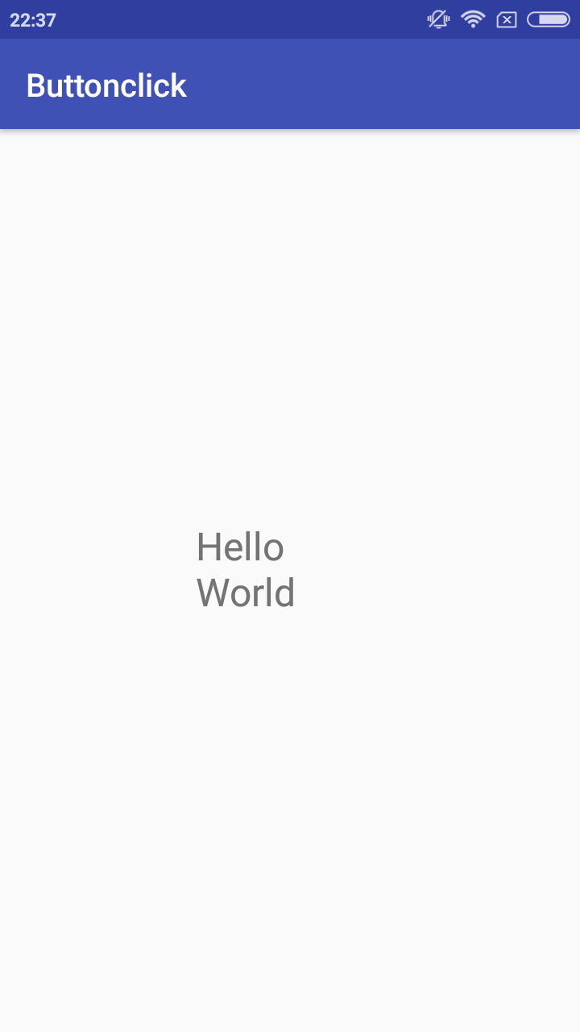

PRACTICAL 2

**Aim: Demonstrate the use of Layout**

simple calculator

**Xmlfile**

*<?***xml version="1.0" encoding="utf-8"***?>*<**RelativeLayoutxmlns:android="http://schemas.android.com/apk/res/android"  
xmlns:app="http://schemas.android.com/apk/res-auto"  
xmlns:tools="http://schemas.android.com/tools"  
android:layout_width="match_parent"  
android:layout_height="match_parent"  
tools:context="com.example.ashok.calculator.MainActivity"**>  
  
<**TextView  
android:id="@+id/textView"  
android:layout_width="159dp"  
android:layout_height="57dp"  
android:text="enter a no"  
android:textSize="24sp"  
app:layout_constraintBottom_toBottomOf="parent"  
app:layout_constraintHorizontal_bias="0.129"  
app:layout_constraintLeft_toLeftOf="parent"  
app:layout_constraintRight_toRightOf="parent"  
app:layout_constraintTop_toTopOf="parent"  
app:layout_constraintVertical_bias="0.068"** />  
  
<**EditText  
android:id="@+id/e1"  
android:layout_width="140dp"  
android:layout_height="52dp"  
android:ems="10"  
android:inputType="textPersonName"  
app:layout_constraintBottom_toBottomOf="parent"  
app:layout_constraintHorizontal_bias="0.878"  
app:layout_constraintLeft_toLeftOf="parent"  
app:layout_constraintRight_toRightOf="parent"  
app:layout_constraintTop_toTopOf="parent"  
app:layout_constraintVertical_bias="0.067"** />  
  
<**TextView  
android:id="@+id/textView2"  
android:layout_width="158dp"  
android:layout_height="52dp"  
android:text="enter a no"  
android:textSize="24sp"  
app:layout_constraintBottom_toBottomOf="parent"  
app:layout_constraintHorizontal_bias="0.129"  
app:layout_constraintLeft_toLeftOf="parent"  
app:layout_constraintRight_toRightOf="parent"  
app:layout_constraintTop_toTopOf="parent"  
app:layout_constraintVertical_bias="0.235"** />  
  
<**EditText  
android:id="@+id/e2"  
android:layout_width="140dp"  
android:layout_height="52dp"  
android:ems="10"  
android:inputType="textPersonName"  
app:layout_constraintBottom_toBottomOf="parent"  
app:layout_constraintHorizontal_bias="0.877"  
app:layout_constraintLeft_toLeftOf="parent"  
app:layout_constraintRight_toRightOf="parent"  
app:layout_constraintTop_toTopOf="parent"  
app:layout_constraintVertical_bias="0.233"** />  
  
<**TextView  
android:id="@+id/tv"  
android:layout_width="191dp"  
android:layout_height="70dp"  
android:text="Result"  
android:textSize="24sp"  
app:layout_constraintBottom_toBottomOf="parent"  
app:layout_constraintLeft_toLeftOf="parent"  
app:layout_constraintRight_toRightOf="parent"  
app:layout_constraintTop_toTopOf="parent"  
app:layout_constraintVertical_bias="0.818"** />  
  
<**Button  
android:id="@+id/b1"  
android:layout_width="103dp"  
android:layout_height="66dp"  
android:text="+"  
android:textSize="30sp"  
app:layout_constraintBottom_toBottomOf="parent"  
app:layout_constraintHorizontal_bias="0.202"  
app:layout_constraintLeft_toLeftOf="parent"  
app:layout_constraintRight_toRightOf="parent"  
app:layout_constraintTop_toTopOf="parent"  
app:layout_constraintVertical_bias="0.421"** />  
  
<**Button  
android:id="@+id/b2"  
android:layout_width="103dp"  
android:layout_height="66dp"  
android:text="-"  
android:textSize="30sp"  
app:layout_constraintBottom_toBottomOf="parent"  
app:layout_constraintHorizontal_bias="0.75"  
app:layout_constraintLeft_toLeftOf="parent"  
app:layout_constraintRight_toRightOf="parent"  
app:layout_constraintTop_toTopOf="parent"  
app:layout_constraintVertical_bias="0.42"** />  
  
<**Button  
android:id="@+id/b3"  
android:layout_width="106dp"  
android:layout_height="66dp"  
android:text="*"  
android:textSize="30sp"  
app:layout_constraintBottom_toBottomOf="parent"  
app:layout_constraintHorizontal_bias="0.205"  
app:layout_constraintLeft_toLeftOf="parent"  
app:layout_constraintRight_toRightOf="parent"  
app:layout_constraintTop_toTopOf="parent"  
app:layout_constraintVertical_bias="0.595"** />  
  
<**Button  
android:id="@+id/b4"  
android:layout_width="105dp"  
android:layout_height="70dp"  
android:text="/"  
android:textSize="30sp"  
app:layout_constraintBottom_toBottomOf="parent"  
app:layout_constraintHorizontal_bias="0.761"  
app:layout_constraintLeft_toLeftOf="parent"  
app:layout_constraintRight_toRightOf="parent"  
app:layout_constraintTop_toTopOf="parent"  
app:layout_constraintVertical_bias="0.6"** />  
</**RelativeLayout**>

Javafile

**final** Button b1, b2, b3, b4;  
**final** EditText e1, e2;  
**final** TextView tv;  
e1=(EditText)findViewById(R.id.***e1***);  
e2=(EditText)findViewById(R.id.***e2***);  
tv=(TextView)findViewById(R.id.***tv***);  
b1 =(Button) findViewById(R.id.***b1***);  
b2 =(Button) findViewById(R.id.***b2***);  
b3 =(Button)findViewById(R.id.***b3***);  
b4=(Button)findViewById(R.id.***b4***);  
b1.setOnClickListener(**new** View.OnClickListener() {  
@Override  
**public void** onClick(View v) {  
 String n1,n2;  
 n1=e1.getText().toString();  
 n2=e1.getText().toString();  
**int** op=Integer.*parseInt*(n1)+Integer.*parseInt*(n2);  
tv.setText(op);  
 }  
});  
b2.setOnClickListener(**new** View.OnClickListener() {  
@Override  
**public void** onClick(View v) {  
 String n1,n2;  
 n1=e1.getText().toString();  
 n2=e1.getText().toString();  
**int** op=Integer.*parseInt*(n1)-Integer.*parseInt*(n2);  
tv.setText(op);  
 }  
});  
b3.setOnClickListener(**new** View.OnClickListener() {  
@Override  
**public void** onClick(View v) {  
 String n1,n2;  
 n1=e1.getText().toString();  
 n2=e1.getText().toString();  
**int** op=Integer.*parseInt*(n1)*Integer.*parseInt*(n2);  
tv.setText(op);  
 }  
});  
b4.setOnClickListener(**new** View.OnClickListener() {  
@Override  
**public void** onClick(View v) {  
 String n1,n2;  
 n1=e1.getText().toString();  
 n2=e1.getText().toString();  
**int** op=Integer.*parseInt*(n1)/Integer.*parseInt*(n2);  
tv.setText(op);  
 }  
});

addition operation

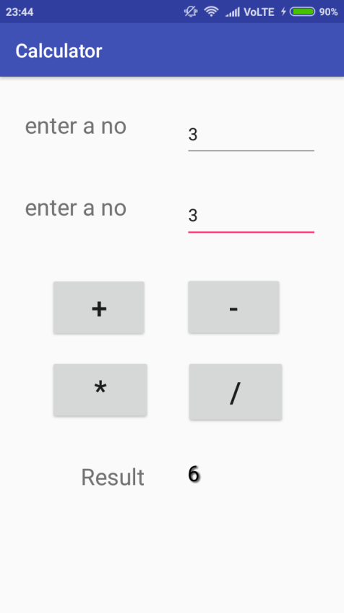

division operation

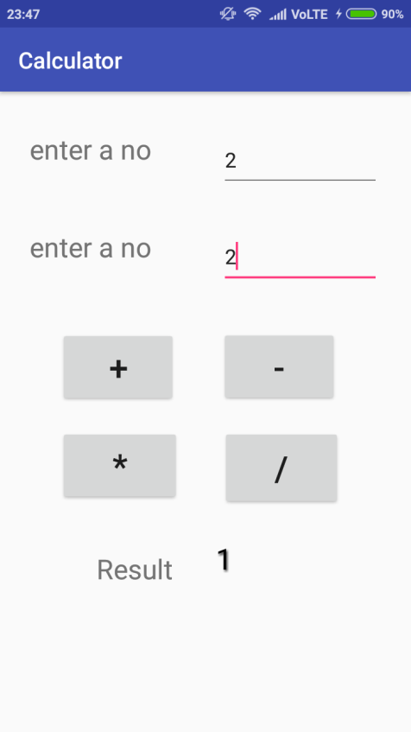

PRACTICAL 3

**Aim: Programs on Dialogs ,Menus**

dialogs

a]TIMEPICKER VIEW

Xml File

*<?***xml version="1.0" encoding="utf-8"***?>*<**android.support.constraint.ConstraintLayoutxmlns:android="http://schemas.android.com/apk/res/android"  
xmlns:app="http://schemas.android.com/apk/res-auto"  
xmlns:tools="http://schemas.android.com/tools"  
android:layout_width="match_parent"  
android:layout_height="match_parent"  
tools:context="com.example.ashok.timepicker.MainActivity"**>  
<**TextView  
android:id="@+id/tv"  
android:layout_width="157dp"  
android:layout_height="118dp"  
android:textSize="24sp"  
app:layout_constraintBottom_toBottomOf="parent"  
app:layout_constraintLeft_toLeftOf="parent"  
app:layout_constraintRight_toRightOf="parent"  
app:layout_constraintTop_toTopOf="parent"  
app:layout_constraintVertical_bias="0.721"** />  
<**Button  
android:id="@+id/button"  
android:layout_width="174dp"  
android:layout_height="128dp"  
android:text="Show Timepicker"  
app:layout_constraintBottom_toBottomOf="parent"  
app:layout_constraintHorizontal_bias="0.522"  
app:layout_constraintLeft_toRightOf="parent"  
app:layout_constraintRight_toRightOf="parent"  
app:layout_constraintTop_toTopOf="parent"  
app:layout_constraintVertical_bias="0.282"** />  
</**android.support.constraint.ConstraintLayout**>

Java File

**final** Button btn=(Button)findViewById(R.id.***button***);  
**final** TextView tv=(TextView)findViewById(R.id.***tv***);  
btn.setOnClickListener(**new** View.OnClickListener() {  
@Override  
**public void** onClick(View view) {  
 Calendar cal=Calendar.*getInstance*();  
**int** our_hours=cal.get(Calendar.***HOUR_OF_DAY***);  
**int** our_min=cal.get(Calendar.***MINUTE***);  
TimePickerDialogtpd=**new** TimePickerDialog(MainActivity.**this**, **new** TimePickerDialog.OnTimeSetListener() {  
@Override  
**public void** onTimeSet(TimePicker view, **int** hourofday, **int** minute) {  
tv.setText(**"Time is"**+hourofday+**":"**+minute);  
 }  
 },our_hours,our_min,**true**);  
tpd.show();  
 }  
 });

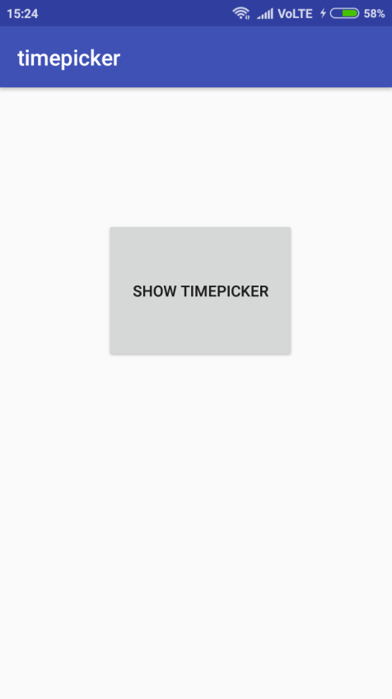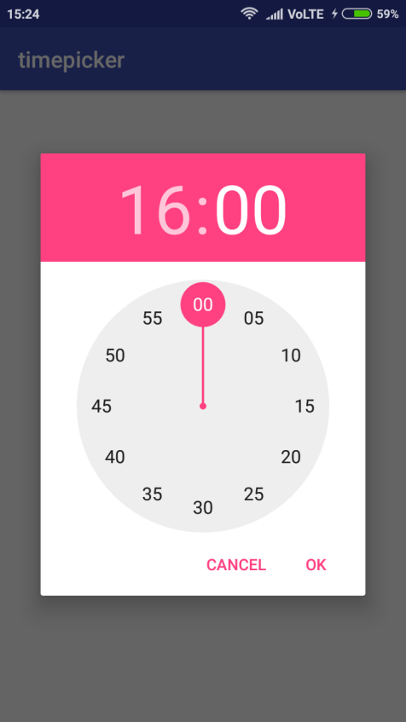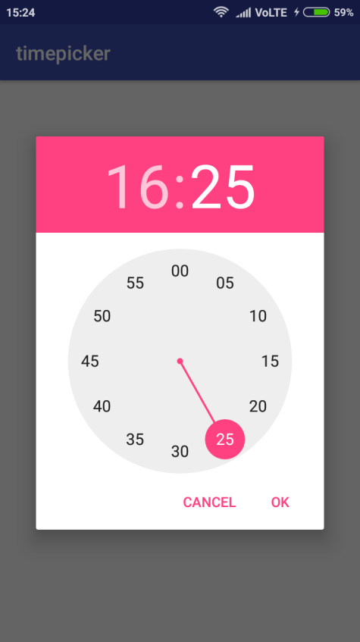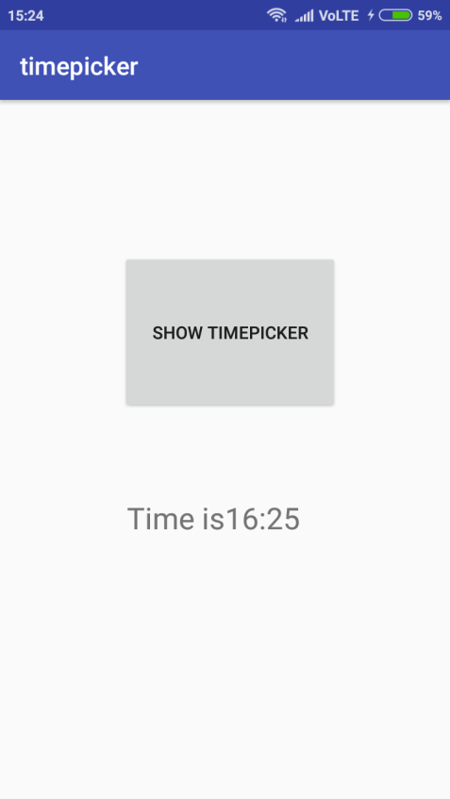

b)datepicker view

Xml File

*<?***xml version="1.0" encoding="utf-8"***?>*<**android.support.constraint.ConstraintLayoutxmlns:android="http://schemas.android.com/apk/res/android"  
xmlns:app="http://schemas.android.com/apk/res-auto"  
xmlns:tools="http://schemas.android.com/tools"  
android:layout_width="match_parent"  
android:layout_height="match_parent"  
tools:context="com.example.ashok.datepicker.MainActivity"**>  
<**Button  
android:id="@+id/button"  
android:layout_width="wrap_content"  
android:layout_height="wrap_content"  
android:padding="@android:dimen/app_icon_size"  
android:text="@string/show_datepicker"  
app:layout_constraintBottom_toBottomOf="parent"  
app:layout_constraintHorizontal_bias="0.416"  
app:layout_constraintLeft_toLeftOf="parent"  
app:layout_constraintRight_toRightOf="parent"  
app:layout_constraintTop_toTopOf="parent"  
app:layout_constraintVertical_bias="0.181"  
app:layout_editor_absoluteX="@android:dimen/app_icon_size"  
app:layout_editor_absoluteY="@android:dimen/app_icon_size"** />  
<**TextView  
android:id="@+id/textView"  
android:layout_width="245dp"  
android:layout_height="91dp"  
android:hint="@string/date"  
android:paddingEnd="@android:dimen/notification_large_icon_height"  
android:paddingLeft="@android:dimen/app_icon_size"  
android:paddingRight="@android:dimen/notification_large_icon_height"  
android:paddingStart="@android:dimen/app_icon_size"  
app:layout_constraintBottom_toBottomOf="parent"  
app:layout_constraintHorizontal_bias="0.417"  
app:layout_constraintLeft_toLeftOf="parent"  
app:layout_constraintRight_toRightOf="parent"  
app:layout_constraintTop_toTopOf="parent"  
app:layout_constraintVertical_bias="0.583"** />  
</**android.support.constraint.ConstraintLayout**>

Javafile

**final** Button btn=(Button)findViewById(R.id.***button***);  
**final** TextView tv=(TextView)findViewById(R.id.***textView***);  
btn.setOnClickListener(**new** View.OnClickListener() {  
@Override  
**public void** onClick(View view) {  
 Calendar cal=Calendar.*getInstance*();  
**int** our_day=cal.get(Calendar.***DAY_OF_MONTH***);  
**int** our_month=cal.get(Calendar.***MONTH***);  
**int** our_year=cal.get(Calendar.***YEAR***);  
DatePickerDialogdpd=**new** DatePickerDialog(MainActivity.**this**, **new** DatePickerDialog.OnDateSetListener() {  
@Override  
**public void** onDateSet(DatePicker view, **int** year, **int** monthofyear, **int** dayofmonth) {  
tv.setText(**"Date is"**+dayofmonth+**"/"**+monthofyear+**"/"**+year);  
 }  
 },our_year,our_month,our_day);  
dpd.show();  
 }  
});

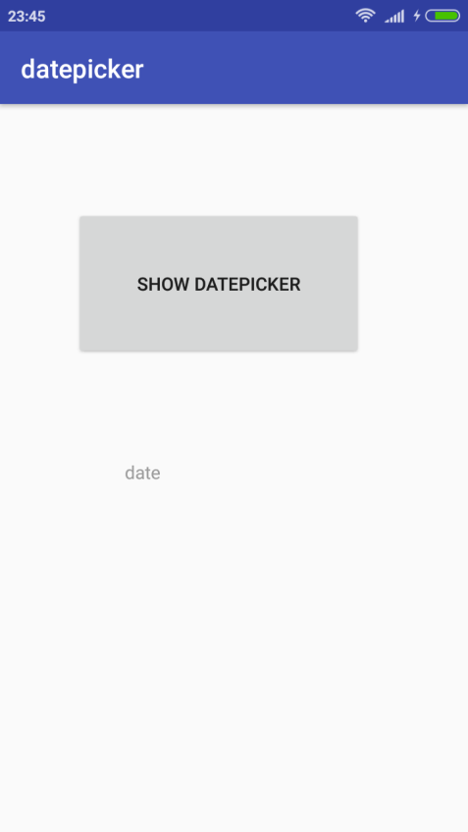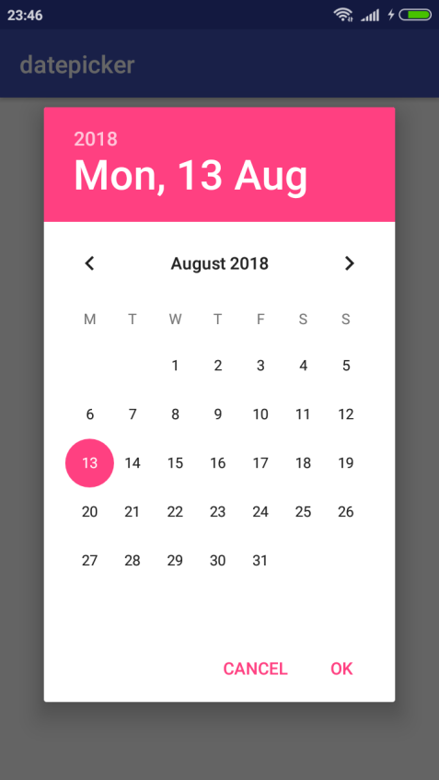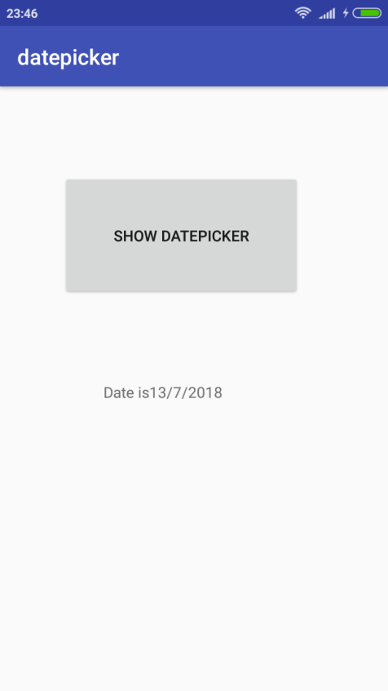

c)Alert

Xmlfile

*<?***xml version="1.0" encoding="utf-8"***?>*<**android.support.constraint.ConstraintLayoutxmlns:android="http://schemas.android.com/apk/res/android"  
xmlns:app="http://schemas.android.com/apk/res-auto"  
xmlns:tools="http://schemas.android.com/tools"  
android:layout_width="match_parent"  
android:layout_height="match_parent"  
tools:context="com.example.ashok.alert.MainActivity"**>  
<**Button  
android:id="@+id/button"  
android:layout_width="226dp"  
android:layout_height="150dp"  
android:text="@string/alert_show"  
app:layout_constraintBottom_toTopOf="parent"  
app:layout_constraintLeft_toRightOf="parent"  
app:layout_constraintRight_toLeftOf="parent"  
app:layout_constraintTop_toBottomOf="parent"** />  
</**android.support.constraint.ConstraintLayout**>

Javafile

**final** Button b=(Button)findViewById(R.id.***button***);  
b.setOnClickListener(**new** View.OnClickListener() {  
@Override  
**public void** onClick(View view) {  
AlertDialog.Builder alert=**new** AlertDialog.Builder(MainActivity.**this**);  
alert.setTitle(**"My alert box"**);  
alert.setMessage(**"Do you want to continue"**);  
alert.setPositiveButton(**"ok"**, **new** DialogInterface.OnClickListener() {  
@Override  
**public void** onClick(DialogInterfacedialogInterface, **int** i) {  
Toast.*makeText*(MainActivity.**this**, **"ok choosed"**, Toast.***LENGTH_SHORT***).show();  
 }  
 });  
alert.setNegativeButton(**"cancel"**, **new** DialogInterface.OnClickListener() {  
@Override  
**public void** onClick(DialogInterfacedialogInterface, **int** i) {  
Toast.*makeText*(MainActivity.**this**, **"cancel choosed"**, Toast.***LENGTH_SHORT***).show();  
 }  
 });  
alert.show();  
 }  
});

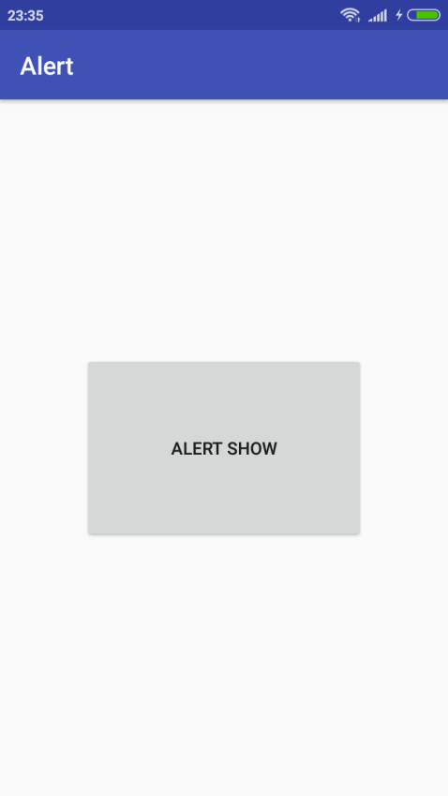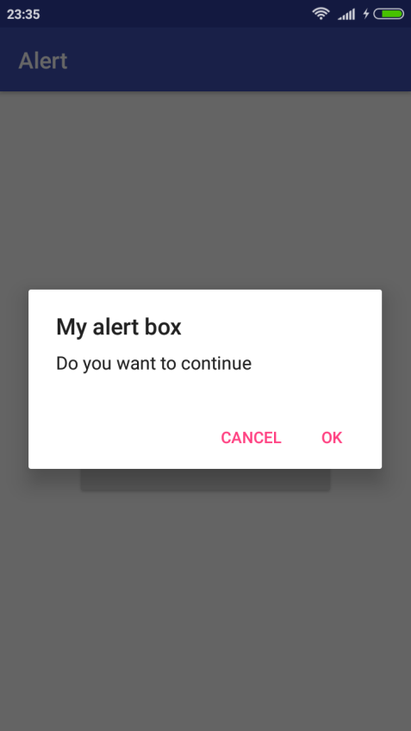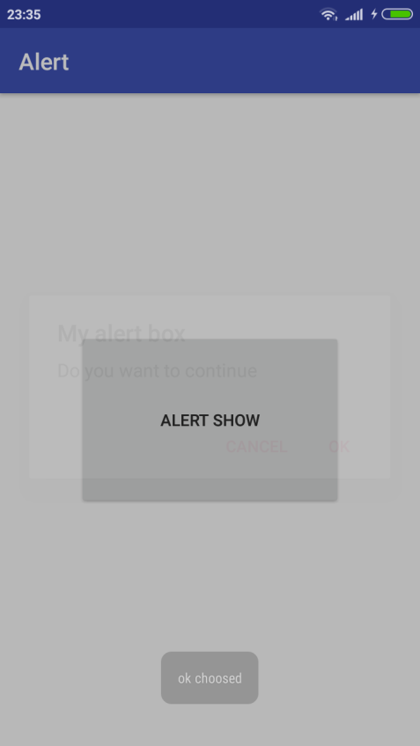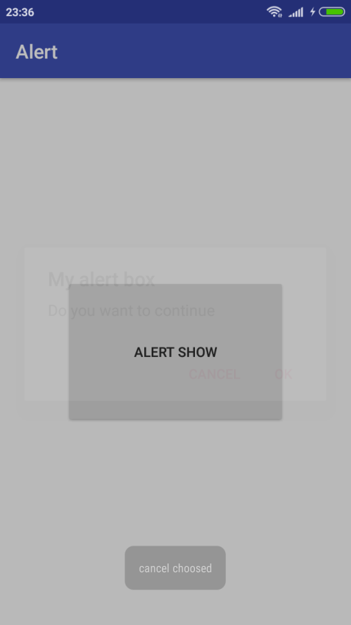

MENUS

a)option menu

Xmlfile

activity_main.xml

*<?***xml version="1.0" encoding="utf-8"***?>*<**android.support.constraint.ConstraintLayoutxmlns:android="http://schemas.android.com/apk/res/android"  
xmlns:app="http://schemas.android.com/apk/res-auto"  
xmlns:tools="http://schemas.android.com/tools"  
android:layout_width="match_parent"  
android:layout_height="match_parent"  
tools:context="com.example.ashok.optionmenu.MainActivity"**>  
  
</**android.support.constraint.ConstraintLayout**>

menu.xml

*<?***xml version="1.0" encoding="utf-8"***?>*<**menu xmlns:android="http://schemas.android.com/apk/res/android"**>  
<**item  
android:id="@+id/a1"  
android:title="Add"**/>  
<**item  
android:id="@+id/a2"  
android:title="Edit"**/>  
<**item  
android:id="@+id/a3"  
android:title="Delete"**/>  
<**item  
android:id="@+id/a4"  
android:title="Save"**/>  
  
</**menu**>

Javafile

**package** com.example.ashok.optionmenu;  
  
**import** android.support.v7.app.AppCompatActivity;  
**import** android.os.Bundle;  
**import** android.view.Menu;  
**import** android.view.MenuInflater;  
**import** android.view.MenuItem;  
**import** android.widget.Toast;  
  
**public class** MainActivity**extends** AppCompatActivity {  
  
@Override  
**protected void** onCreate(Bundle savedInstanceState) {  
**super**.onCreate(savedInstanceState);  
setContentView(R.layout.***activity_main***);  
  
 }  
  
@Override  
**public boolean**onCreateOptionsMenu(Menu menu) {  
MenuInflater mi=getMenuInflater();  
mi.inflate(R.menu.***menu***,menu);  
**return super**.onCreateOptionsMenu(menu);  
 }  
  
@Override  
**public boolean**onOptionsItemSelected(MenuItem item) {  
**switch**(item.getItemId())  
 {  
**case** R.id.***a1***:  
Toast.*makeText*(MainActivity.**this**,**"add is selected"**,Toast.***LENGTH_SHORT***).show();  
**break**;  
**case** R.id.***a2***:  
Toast.*makeText*(MainActivity.**this**,**"edit is selected"**,Toast.***LENGTH_SHORT***).show();  
**break**;  
**case** R.id.***a3***:  
Toast.*makeText*(MainActivity.**this**,**"delete is selected"**,Toast.***LENGTH_SHORT***).show();  
**break**;  
**case** R.id.***a4***:  
Toast.*makeText*(MainActivity.**this**,**"save is selected"**,Toast.***LENGTH_SHORT***).show();  
**break**;  
**default**:  
Toast.*makeText*(MainActivity.**this**,**"please select options"**,Toast.***LENGTH_SHORT***).show();  
 }  
**return super**.onOptionsItemSelected(item);  
 }  
}

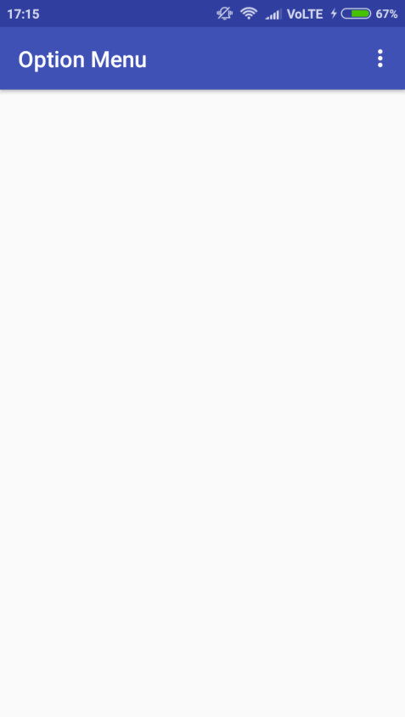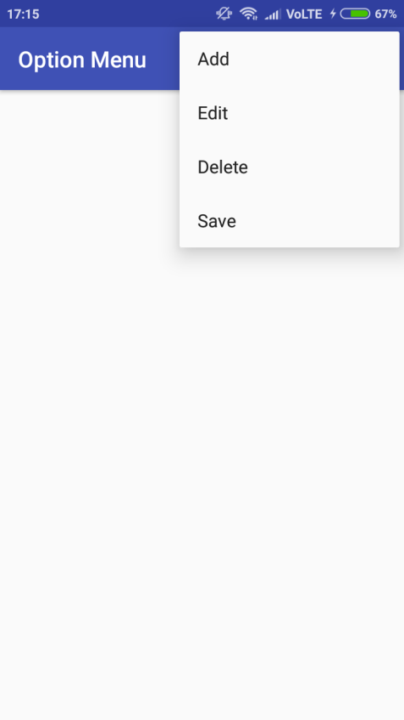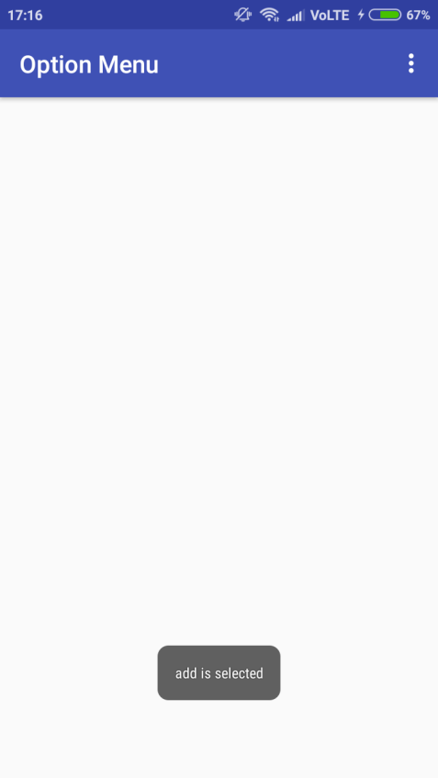

b)context menu

Xmlfile

activitymain.xml

*<?***xml version="1.0" encoding="utf-8"***?>*<**android.support.constraint.ConstraintLayoutxmlns:android="http://schemas.android.com/apk/res/android"  
xmlns:app="http://schemas.android.com/apk/res-auto"  
xmlns:tools="http://schemas.android.com/tools"  
android:layout_width="match_parent"  
android:layout_height="match_parent"  
tools:context="com.example.ashok.contextmenu.MainActivity"**>  
  
<**Button  
android:id="@+id/button"  
android:layout_width="219dp"  
android:layout_height="108dp"  
android:text="Click"  
app:layout_constraintBottom_toBottomOf="parent"  
app:layout_constraintBottom_toTopOf="parent"  
app:layout_constraintLeft_toLeftOf="parent"  
app:layout_constraintRight_toRightOf="parent"  
app:layout_constraintTop_toTopOf="parent"  
app:layout_constraintVertical_bias="0.31"** />  
  
</**android.support.constraint.ConstraintLayout**>

menu.xml

*<?***xml version="1.0" encoding="utf-8"***?>*<**menu xmlns:android="http://schemas.android.com/apk/res/android"**>  
<**item  
android:id="@+id/a1"  
android:title="Add"**/>  
<**item  
android:id="@+id/a2"  
android:title="Edit"**/>  
<**item  
android:id="@+id/a3"  
android:title="Delete"**/>  
<**item  
android:id="@+id/a4"  
android:title="Save"**/>  
  
</**menu**>

Javafile

**package** com.example.ashok.contextmenu;  
  
**import** android.support.v7.app.AppCompatActivity;  
**import** android.os.Bundle;  
**import** android.view.ContextMenu;  
**import** android.view.MenuInflater;  
**import** android.view.MenuItem;  
**import** android.view.View;  
**import** android.widget.Button;  
**import** android.widget.Toast;  
  
**public class** MainActivity**extends** AppCompatActivity {  
  
@Override  
**protected void** onCreate(Bundle savedInstanceState) {  
**super**.onCreate(savedInstanceState);  
setContentView(R.layout.***activity_main***);  
 Button btn=(Button)findViewById(R.id.***button***);  
registerForContextMenu(btn);}  
  
@Override  
**public void** onCreateContextMenu(ContextMenu menu, View v, ContextMenu.ContextMenuInfomenuInfo) {  
MenuInflater m=getMenuInflater();  
m.inflate(R.menu.***menu***,menu);  
  
**super**.onCreateContextMenu(menu, v, menuInfo);  
 }  
  
@Override  
**public boolean**onContextItemSelected(MenuItem item) {  
**switch**(item.getItemId())  
 {  
**case** R.id.***a1***:  
Toast.*makeText*(MainActivity.**this**,**"add is selected"**,Toast.***LENGTH_SHORT***).show();  
**break**;  
**case** R.id.***a2***:  
Toast.*makeText*(MainActivity.**this**,**"edit is selected"**,Toast.***LENGTH_SHORT***).show();  
**break**;  
**case** R.id.***a3***:  
Toast.*makeText*(MainActivity.**this**,**"delete is selected"**,Toast.***LENGTH_SHORT***).show();  
**break**;  
**case** R.id.***a4***:  
Toast.*makeText*(MainActivity.**this**,**"save is selected"**,Toast.***LENGTH_SHORT***).show();  
**break**;  
**default**:  
Toast.*makeText*(MainActivity.**this**,**"please select options"**,Toast.***LENGTH_SHORT***).show();  
 }  
**return super**.onOptionsItemSelected(item);  
 }

}

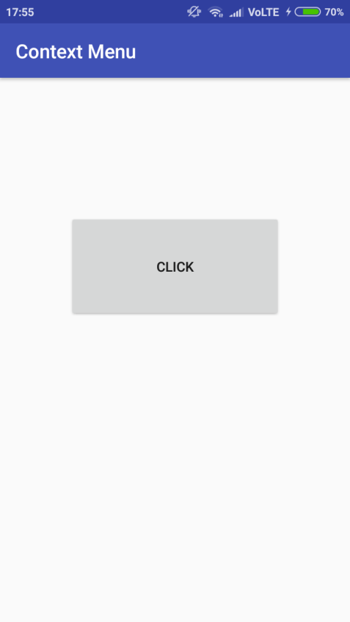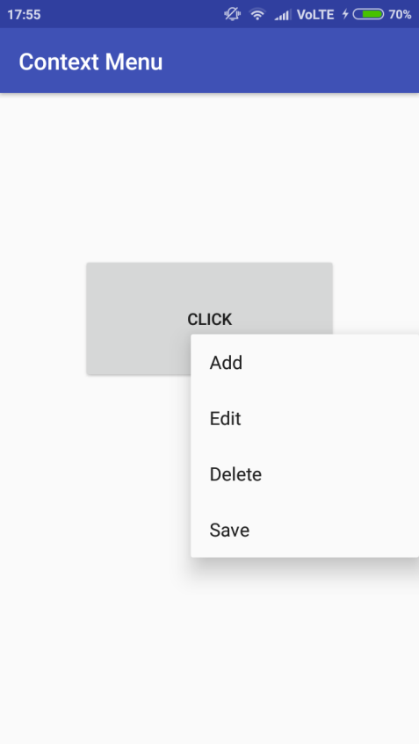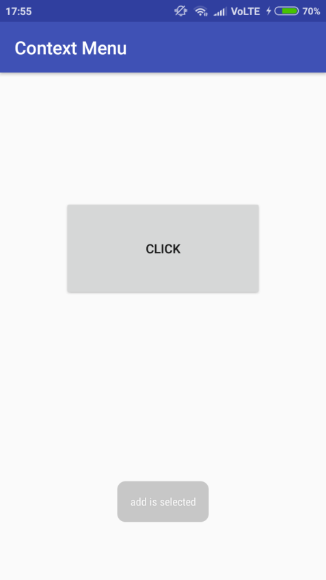

c)popup menu

Xmlfile

activity_main.xml

*<?***xml version="1.0" encoding="utf-8"***?>*<**android.support.constraint.ConstraintLayoutxmlns:android="http://schemas.android.com/apk/res/android"  
xmlns:app="http://schemas.android.com/apk/res-auto"  
xmlns:tools="http://schemas.android.com/tools"  
android:layout_width="match_parent"  
android:layout_height="match_parent"  
tools:context="com.example.ashok.contextmenu.MainActivity"**>  
  
<**Button  
android:id="@+id/button"  
android:layout_width="219dp"  
android:layout_height="108dp"  
android:text="Click"  
app:layout_constraintBottom_toBottomOf="parent"  
app:layout_constraintBottom_toTopOf="parent"  
app:layout_constraintLeft_toLeftOf="parent"  
app:layout_constraintRight_toRightOf="parent"  
app:layout_constraintTop_toTopOf="parent"  
app:layout_constraintVertical_bias="0.31"** />  
  
</**android.support.constraint.ConstraintLayout**>

menu.xml

*<?***xml version="1.0" encoding="utf-8"***?>*<**menu xmlns:android="http://schemas.android.com/apk/res/android"**>  
<**item  
android:id="@+id/a1"  
android:title="Add"**/>  
<**item  
android:id="@+id/a2"  
android:title="Edit"**/>  
<**item  
android:id="@+id/a3"  
android:title="Delete"**/>  
<**item  
android:id="@+id/a4"  
android:title="Save"**/>  
  
</**menu**>

Javafile

**import** android.support.v7.app.ActionBar;  
**import** android.support.v7.app.AppCompatActivity;  
**import** android.os.Bundle;  
**import** android.view.ContextMenu;  
**import** android.view.MenuInflater;  
**import** android.view.MenuItem;  
**import** android.view.View;  
**import** android.widget.Button;  
**import** android.widget.PopupMenu;  
**import** android.widget.Toast;  
  
**public class** MainActivity**extends** AppCompatActivity {  
  
@Override  
**protected void** onCreate(Bundle savedInstanceState) {  
**super**.onCreate(savedInstanceState);  
setContentView(R.layout.activity_main);  
 Button btn = (Button) findViewById(R.id.***button***);  
**final** PopupMenu pm = **new** PopupMenu(MainActivity.**this**, btn);  
pm.inflate(R.menu.***menu***);  
btn.setOnClickListener(**new** View.OnClickListener() {  
@Override  
**public void** onClick(View view) {  
pm.show();  
  
 }  
 });  
pm.setOnMenuItemClickListener(**new** PopupMenu.OnMenuItemClickListener() {  
@Override  
**public boolean**onMenuItemClick(MenuItem item) {  
**switch** (item.getItemId()) {  
**case** R.id.***a1***:  
Toast.*makeText*(MainActivity.**this**, **"add is selected"**, Toast.***LENGTH_SHORT***).show();  
**break**;  
**case** R.id.***a2***:  
Toast.*makeText*(MainActivity.**this**, **"edit is selected"**, Toast.***LENGTH_SHORT***).show();  
**break**;  
**case** R.id.***a3***:  
Toast.*makeText*(MainActivity.**this**, **"delete is selected"**, Toast.***LENGTH_SHORT***).show();  
**break**;  
**case** R.id.***a4***:  
Toast.*makeText*(MainActivity.**this**, **"save is selected"**, Toast.***LENGTH_SHORT***).show();  
**break**;  
**default**:  
Toast.*makeText*(MainActivity.**this**, **"please select options"**, Toast.***LENGTH_SHORT***).show();  
 }  
**return false**;  
 }  
 });  
 }}

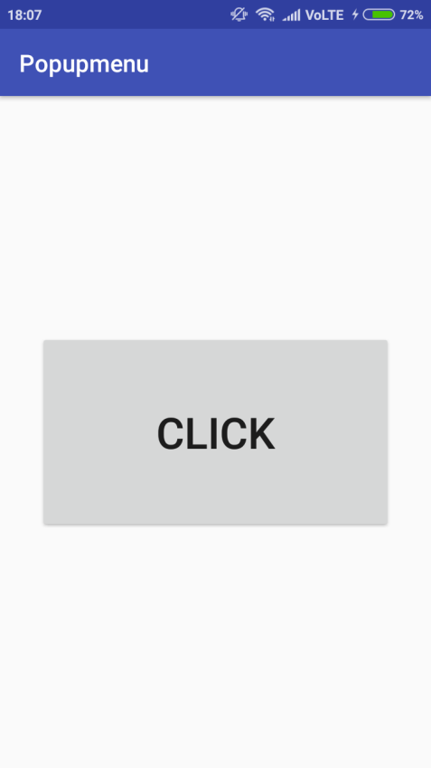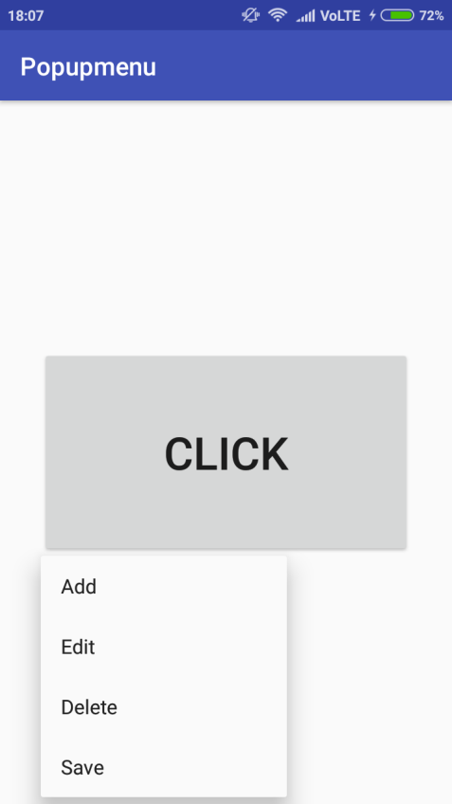

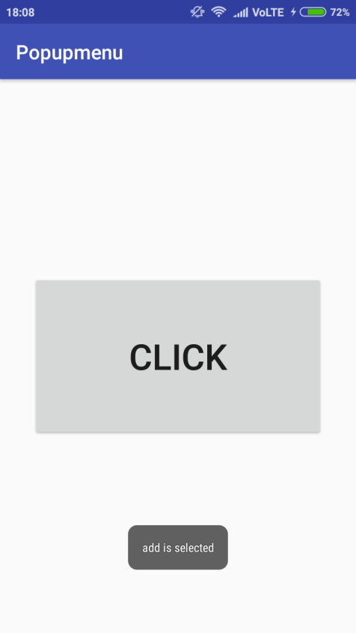

PRACTICAL 4

**Aim: Program on Intents,Events,Listeners and Adapters**

MainActivity.xml

*<?***xml version="1.0" encoding="utf-8"***?>*<**RelativeLayoutxmlns:android="http://schemas.android.com/apk/res/android"  
xmlns:app="http://schemas.android.com/apk/res-auto"  
xmlns:tools="http://schemas.android.com/tools"  
android:layout_width="match_parent"  
android:layout_height="match_parent"  
tools:context=".MainActivity"  
android:orientation="horizontal"**>  
  
<**AutoCompleteTextView  
android:id="@+id/actv1"  
android:layout_width="267dp"  
android:layout_height="wrap_content"  
android:layout_alignParentTop="true"  
android:layout_centerHorizontal="true"  
android:layout_marginTop="227dp"  
android:contentDescription="enter name of sports"** />  
  
<**Button  
android:id="@+id/b1"  
android:layout_width="wrap_content"  
android:layout_height="wrap_content"  
android:layout_alignParentBottom="true"  
android:layout_centerHorizontal="true"  
android:layout_marginBottom="210dp"  
android:text="WIKI-SEARCH"** />  
  
<**TextView  
android:id="@+id/textView"  
android:layout_width="226dp"  
android:layout_height="wrap_content"  
android:layout_alignParentTop="true"  
android:layout_centerHorizontal="true"  
android:layout_marginTop="165dp"  
android:text="SEARCH FOR SPORTS DETAILS:"  
android:textSize="20dp"** />  
</**RelativeLayout**>

MainActivity.java

**package** com.example.acer.demo;  
  
**import** android.content.Intent;  
**import** android.net.Uri;  
**import** android.support.v7.app.AppCompatActivity;  
**import** android.os.Bundle;  
**import** android.view.View;  
**import** android.widget.ArrayAdapter;  
**import** android.widget.AutoCompleteTextView;  
**import** android.widget.Button;  
**import** android.widget.Toast;  
  
**public class** MainActivity**extends**AppCompatActivity {  
  
AutoCompleteTextView**actv1**;  
 Button **b1**;  
ArrayAdapter<String>**a**;  
 String **add**;  
 String[] **games**=**new** String[]{**"Football"**,**"Volleyball"**,**"Baseball"**,**"Batminton"**,**"Cricket"**,**"Hockey"**};  
  
@Override  
**protected void** onCreate(Bundle savedInstanceState) {  
**super**.onCreate(savedInstanceState);  
setContentView(R.layout.***activity_main***);  
  
**actv1**=(AutoCompleteTextView)findViewById(R.id.***actv1***);  
**b1**=(Button)findViewById(R.id.***b1***);  
  
**a**=**new** ArrayAdapter<String>(**this**,android.R.layout.***simple_dropdown_item_1line***,**games**);  
**actv1**.setAdapter(**a**);  
**actv1**.setThreshold(1);  
  
**b1**.setOnClickListener(**new** View.OnClickListener() {  
@Override  
**public void** onClick(View view) {  
**add**=**actv1**.getText().toString();  
 String url=**"https://en.wikipedia.org/wiki/"** + **add**;  
Toast.*makeText*(MainActivity.**this**,url,Toast.***LENGTH_LONG***).show();  
 Intent i = **new** Intent(Intent.***ACTION_VIEW***, Uri.*parse*(url));  
startActivity(i);  
 }  
 });  
 }  
}

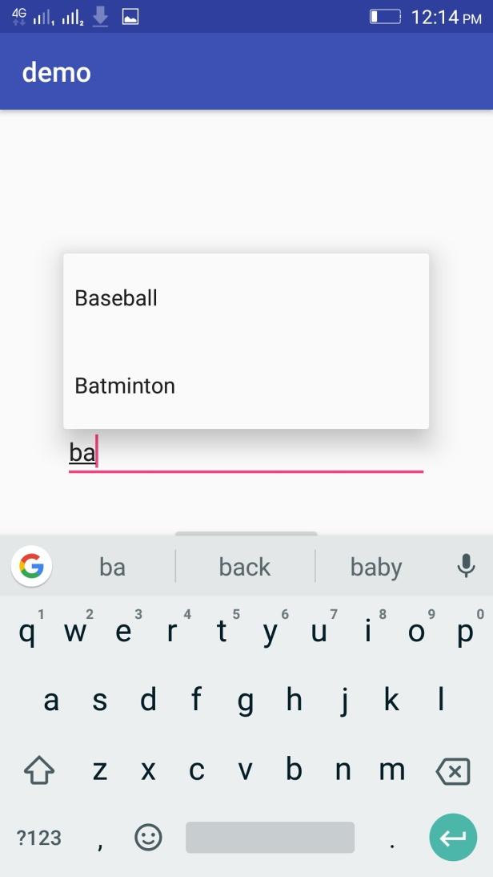

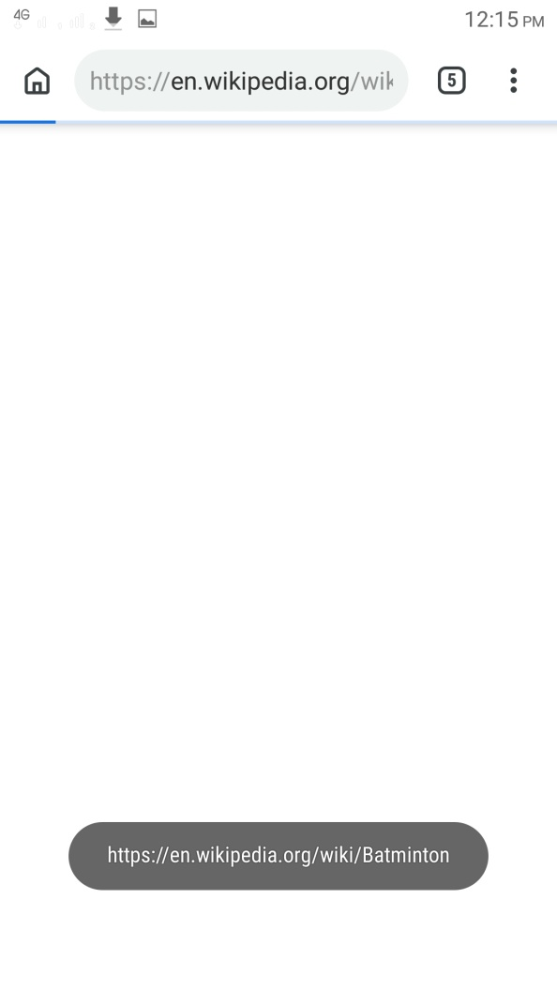

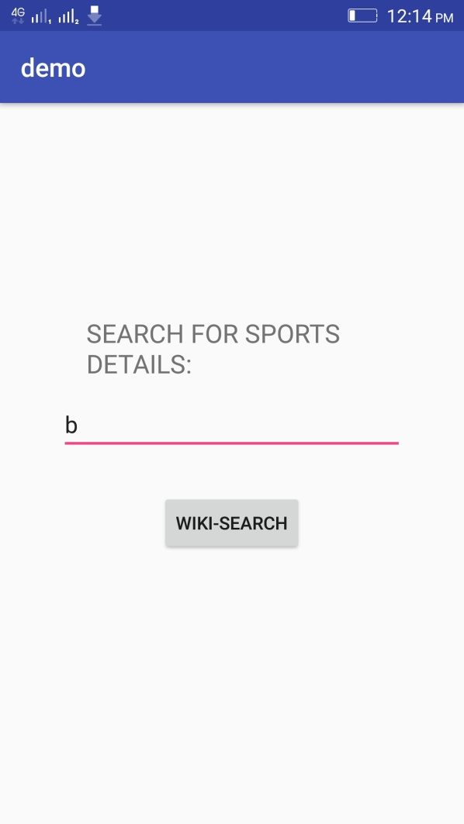

B] screen navigation

Xmlfile

*<?***xml version="1.0" encoding="utf-8"***?>*<**RelativeLayoutxmlns:android="http://schemas.android.com/apk/res/android"  
xmlns:tools="http://schemas.android.com/tools"  
android:layout_width="match_parent"  
android:layout_height="match_parent"  
android:paddingBottom="@dimen/activity_vertical_margin"  
android:paddingLeft="@dimen/activity_horizontal_margin"  
android:paddingRight="@dimen/activity_horizontal_margin"  
android:paddingTop="@dimen/activity_vertical_margin"  
tools:context="com.example.sys.myapplication.MainActivity"**>  
  
<**Button  
android:layout_width="wrap_content"  
android:layout_height="wrap_content"  
android:text="New Button"  
android:id="@+id/button"  
android:layout_centerVertical="true"  
android:layout_centerHorizontal="true"** />  
</**RelativeLayout**>

Javafile

Mainactivity.java

**package** com.example.sys.myapplication;  
  
**import** android.content.Intent;  
**import** android.support.v7.app.AppCompatActivity;  
**import** android.os.Bundle;  
**import** android.view.View;  
**import** android.widget.Button;  
  
**public class** MainActivity**extends** AppCompatActivity {  
  
@Override  
**protected void** onCreate(Bundle savedInstanceState) {  
**super**.onCreate(savedInstanceState);  
setContentView(R.layout.***activity_main***);  
 Button b1;  
 b1=(Button)findViewById(R.id.***button***);  
 b1.setOnClickListener(**new** View.OnClickListener() {  
@Override  
**public void** onClick(View view) {  
 Intent intent=**new** Intent(MainActivity.**this**,secondactivity.**class**);  
startActivity(intent);  
 }  
 });  
 }  
}

secondactivity.java

**package** com.example.sys.myapplication;  
  
**import** android.support.v7.app.AppCompatActivity;  
**import** android.os.Bundle;  
  
**public class** secondactivity**extends** AppCompatActivity {  
  
@Override  
**protected void** onCreate(Bundle savedInstanceState) {  
**super**.onCreate(savedInstanceState);  
setContentView(R.layout.***activity_secondactivity***);  
getSupportActionBar().setTitle(**"activity2"**);  
getSupportActionBar().setDisplayHomeAsUpEnabled(**true**);  
 }}

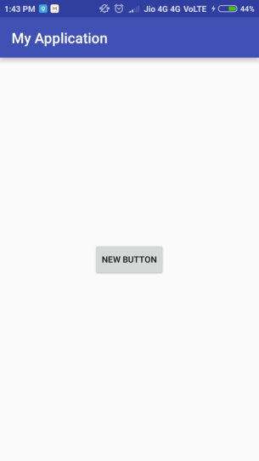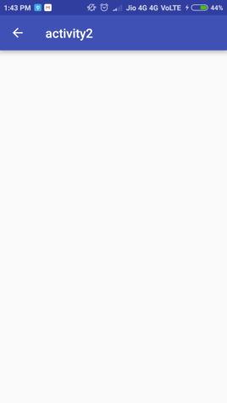

practical 5

**Aim: Programs on Broadcast Receivers, Notifications and Services**

A)use of Broadcast receivers

Xmlfile

*<?***xml version="1.0" encoding="utf-8"***?>*<**android.support.constraint.ConstraintLayoutxmlns:android="http://schemas.android.com/apk/res/android"  
xmlns:app="http://schemas.android.com/apk/res-auto"  
xmlns:tools="http://schemas.android.com/tools"  
android:layout_width="match_parent"  
android:layout_height="match_parent"  
tools:context="com.example.ashok.myapplication.MainActivity"**>  
  
<**TextView  
android:id="@+id/textfield"  
android:layout_width="193dp"  
android:layout_height="100dp"  
android:layout_gravity="center"  
app:layout_constraintBottom_toBottomOf="parent"  
app:layout_constraintHorizontal_bias="0.502"  
app:layout_constraintLeft_toLeftOf="parent"  
app:layout_constraintRight_toRightOf="parent"  
app:layout_constraintTop_toTopOf="parent"  
app:layout_constraintVertical_bias="0.153"** />  
  
<**ProgressBar  
android:id="@+id/progressbar"  
style="?android:attr/progressBarStyleHorizontal"  
android:layout_width="wrap_content"  
android:layout_height="wrap_content"  
android:layout_gravity="center"  
android:max="100"  
android:minHeight="100dip"  
android:minWidth="200dip"  
app:layout_constraintBottom_toBottomOf="parent"  
app:layout_constraintLeft_toLeftOf="parent"  
app:layout_constraintRight_toRightOf="parent"  
app:layout_constraintTop_toTopOf="parent"  
app:layout_constraintVertical_bias="0.498"** />  
  
</**android.support.constraint.ConstraintLayout**>

Javafile

**package** com.example.ashok.myapplication;  
**import** android.content.BroadcastReceiver;  
**import** android.content.Context;  
**import** android.content.Intent;  
**import** android.content.IntentFilter;  
**import** android.support.v7.app.AppCompatActivity;  
**import** android.os.Bundle;  
**import** android.widget.ProgressBar;  
**import** android.widget.TextView;  
  
**public class** MainActivity**extends** AppCompatActivity {  
BroadcastReceiver**broadcastReceiver**=**new** BroadcastReceiver() {  
@Override  
**public void** onReceive(Context context, Intent intent) {  
**int** level=intent.getIntExtra(**"level"**,0);  
ProgressBarprogressBar=(ProgressBar)findViewById(R.id.***progressbar***);  
progressBar.setProgress(level);  
TextView tv=(TextView)findViewById(R.id.***textfield***);  
tv.setText(**"Battery Level: "** + Integer.*toString*(level) + **"%"**);  
 }  
 };  
@Override  
**protected void** onCreate(Bundle savedInstanceState) {  
**super**.onCreate(savedInstanceState);  
setContentView(R.layout.***activity_main***);  
registerReceiver(**broadcastReceiver**, **new** IntentFilter(  
Intent.***ACTION_BATTERY_CHANGED***));  
 }  
}

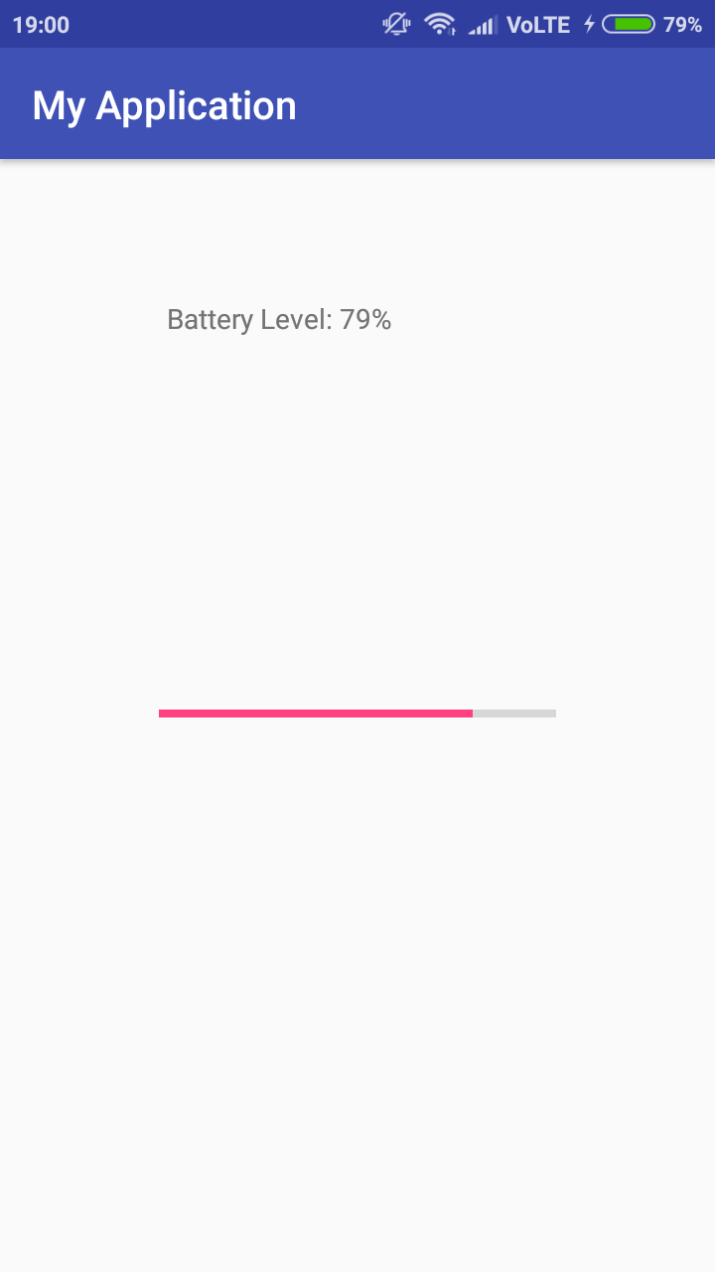

B)notifications

Xmlfile

<**android.support.constraint.ConstraintLayoutxmlns:android="http://schemas.android.com/apk/res/android"  
xmlns:app="http://schemas.android.com/apk/res-auto"  
xmlns:tools="http://schemas.android.com/tools"  
android:layout_width="match_parent"  
android:layout_height="match_parent"  
tools:context="com.example.ashok.myapplication.MainActivity"**>

<**Button  
android:id="@+id/button"  
android:layout_width="158dp"  
android:layout_height="93dp"  
android:onClick="sendnotification"  
android:text="Click"  
app:layout_constraintBottom_toBottomOf="parent"  
app:layout_constraintLeft_toLeftOf="parent"  
app:layout_constraintRight_toRightOf="parent"  
app:layout_constraintTop_toTopOf="parent"  
app:layout_constraintVertical_bias="0.686"** />

</**android.support.constraint.ConstraintLayout**>  
Javafile

**package** com.example.ashok.myapplication;  
**import** android.support.v7.app.AppCompatActivity;  
**import** android.os.Bundle;  
**import** android.app.NotificationManager;  
**import** android.support.v4.app.NotificationCompat;  
**import** android.view.View;  
**import** android.content.Context;  
**public class** MainActivity**extends** AppCompatActivity {  
@Override  
**protected void** onCreate(Bundle savedInstanceState) {  
**super**.onCreate(savedInstanceState);  
setContentView(R.layout.***activity_main***);  
 }  
**public void** sendNotification(View view) {NotificationCompat.BuildermBuilder =**new** NotificationCompat.Builder(**this**).setSmallIcon(R.drawable.notification_icon)

.setContentTitle(**"My notification"**).setContentText(**"Hello World!"**);  
  
NotificationManagermNotificationManager =(NotificationManager) getSystemService(Context.***NOTIFICATION_SERVICE***);  
  
NotificationManager.notify().  
  
mNotificationManager.notify(001, mBuilder.build());

}  
}

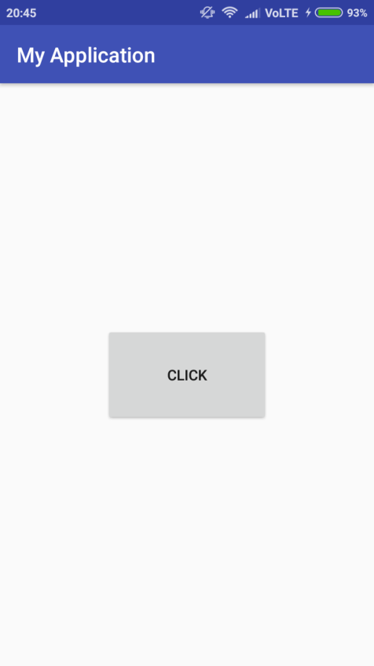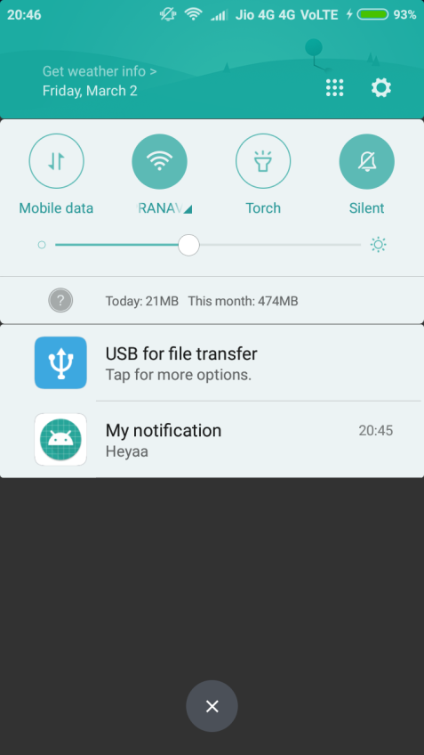

C)SERVICES

activity.xml

*<?***xml version="1.0" encoding="utf-8"***?>*<**RelativeLayoutxmlns:android="http://schemas.android.com/apk/res/android"  
xmlns:tools="http://schemas.android.com/tools"  
android:id="@+id/activity_main"  
android:layout_width="match_parent"  
android:layout_height="match_parent"  
android:paddingBottom="@dimen/activity_vertical_margin"  
android:paddingLeft="@dimen/activity_horizontal_margin"  
android:paddingRight="@dimen/activity_horizontal_margin"  
android:paddingTop="@dimen/activity_vertical_margin"  
tools:context="com.v.sound.MainActivity"**>  
  
<**TextView  
android:layout_width="wrap_content"  
android:layout_height="wrap_content"  
android:text="Hello World!"  
android:id="@+id/textView"** />  
  
<**Button  
android:text="Start Music"  
android:layout_width="wrap_content"  
android:layout_height="wrap_content"  
android:layout_below="@+id/textView"  
android:layout_toRightOf="@+id/textView"  
android:layout_toEndOf="@+id/textView"  
android:layout_marginTop="101dp"  
android:id="@+id/btnStart"  
android:onClick="musicStart"**/>  
  
<**Button  
android:text="Stop music"  
android:layout_width="wrap_content"  
android:layout_height="wrap_content"  
android:layout_centerVertical="true"  
android:layout_alignRight="@+id/btnStart"  
android:layout_alignEnd="@+id/btnStart"  
android:id="@+id/btnStop"  
android:layout_alignLeft="@+id/btnStart"  
android:layout_alignStart="@+id/btnStart"  
android:onClick="musicStop"**/>  
</**RelativeLayout**>

myActivity.java

**package** com.v.sound;  
  
**import** android.content.Intent;  
**import** android.media.MediaPlayer;  
**import** android.support.v7.app.AppCompatActivity;  
**import** android.os.Bundle;  
**import** android.view.View;  
  
**public class** MainActivity**extends** AppCompatActivity {  
 Intent **i**;  
@Override  
**protected void** onCreate(Bundle savedInstanceState) {  
**super**.onCreate(savedInstanceState);  
setContentView(R.layout.***activity_main***);  
 }  
**public void** musicStart(View view)  
 {  
**i**=**new** Intent(MainActivity.**this**,MyService.**class**);  
startService(**i**);  
 }  
**public void** musicStop(View view)  
 {  
stopService(**i**);  
 }  
  
}

MyService.java

**package** com.v.sound;  
  
**import** android.app.Service;  
**import** android.content.Intent;  
**import** android.media.MediaPlayer;  
**import** android.os.IBinder;  
**import** android.support.annotation.Nullable;  
*/**  
 * Created by lab1_pc11 on 12/28/2016.  
 */***public class** MyService**extends** Service {  
MediaPlayer**mediaPlayer**;  
  
@Nullable  
 @Override  
**public** IBinderonBind(Intent intent) {  
**return null**;  
 }  
  
@Override  
**public int** onStartCommand(Intent intent, **int** flags, **int** startId) {  
**mediaPlayer**=MediaPlayer.*create*(getApplicationContext(),R.raw.***kalimba***);  
**mediaPlayer**.start();  
  
  
**return super**.onStartCommand(intent, flags, startId);  
 }  
  
@Override  
**public void** onDestroy() {  
**super**.onDestroy();  
**mediaPlayer**.stop();  
 }  
}

androidmanifest.xml

*<?***xml version="1.0" encoding="utf-8"***?>*<**manifest xmlns:android="http://schemas.android.com/apk/res/android"  
package="com.v.sound"**>  
  
<**application  
android:allowBackup="true"  
android:icon="@mipmap/ic_launcher"  
android:label="@string/app_name"  
android:supportsRtl="true"  
android:theme="@style/AppTheme"**>  
<**activity android:name=".MainActivity"**>  
<**intent-filter**>  
<**action android:name="android.intent.action.MAIN"** />  
  
<**category android:name="android.intent.category.LAUNCHER"** />  
</**intent-filter**>  
</**activity**>  
  
<**service android:name=".MyService"**/>  
</**application**>  
  
</**manifest**>

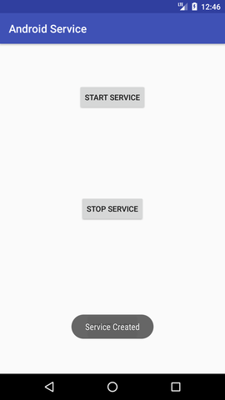

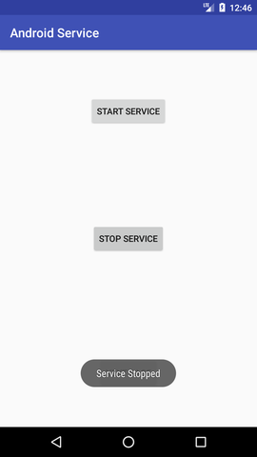

practical 6

**Aim: Programs on SQLite Database**

activity_main.xml

<**RelativeLayoutxmlns:android="http://schemas.android.com/apk/res/android"  
xmlns:tools="http://schemas.android.com/tools" android:layout_width="match_parent"  
android:layout_height="match_parent"  
tools:context=".MainActivity"**>  
  
<**TextView  
android:layout_width="wrap_content"  
android:layout_height="wrap_content"  
android:textAppearance="?android:attr/textAppearanceLarge"  
android:text="Name"  
android:id="@+id/textView"  
android:layout_alignParentTop="true"  
android:layout_alignParentLeft="true"  
android:layout_alignParentStart="true"** />  
  
<**TextView  
android:layout_width="wrap_content"  
android:layout_height="wrap_content"  
android:textAppearance="?android:attr/textAppearanceLarge"  
android:text="Surname"  
android:id="@+id/textView2"  
android:layout_below="@+id/editText_name"  
android:layout_alignParentLeft="true"  
android:layout_alignParentStart="true"** />  
  
<**TextView  
android:layout_width="wrap_content"  
android:layout_height="wrap_content"  
android:textAppearance="?android:attr/textAppearanceLarge"  
android:text="Marks"  
android:id="@+id/textView3"  
android:layout_below="@+id/editText_surname"  
android:layout_alignParentLeft="true"  
android:layout_alignParentStart="true"** />  
  
<**EditText  
android:layout_width="match_parent"  
android:layout_height="wrap_content"  
android:id="@+id/editText_name"  
android:layout_alignTop="@+id/textView"  
android:layout_toRightOf="@+id/textView"  
android:layout_toEndOf="@+id/textView"** />  
  
<**EditText  
android:layout_width="match_parent"  
android:layout_height="wrap_content"  
android:id="@+id/editText_surname"  
android:layout_alignTop="@+id/textView2"  
android:layout_toRightOf="@+id/textView2"  
android:layout_toEndOf="@+id/textView2"** />  
  
<**EditText  
android:layout_width="match_parent"  
android:layout_height="wrap_content"  
android:id="@+id/editText_Marks"  
android:layout_below="@+id/editText_surname"  
android:layout_toRightOf="@+id/textView3"  
android:layout_toEndOf="@+id/textView3"** />  
  
<**Button  
android:id="@+id/button_add"  
android:layout_width="match_parent"  
android:layout_height="wrap_content"  
android:layout_alignParentBottom="true"  
android:layout_centerHorizontal="true"  
android:layout_marginBottom="232dp"  
android:text="Add Data"** />  
  
<**Button  
android:id="@+id/button_viewAll"  
android:layout_width="match_parent"  
android:layout_height="wrap_content"  
android:layout_alignParentBottom="true"  
android:layout_alignParentStart="true"  
android:layout_marginBottom="174dp"  
android:text="View All"** />  
  
<**Button  
android:id="@+id/button_update"  
android:layout_width="match_parent"  
android:layout_height="wrap_content"  
android:layout_alignParentBottom="true"  
android:layout_alignParentStart="true"  
android:layout_marginBottom="112dp"  
android:text="Update"** />  
  
  
<**Button  
android:id="@+id/button_delete"  
android:layout_width="match_parent"  
android:layout_height="wrap_content"  
android:layout_alignParentBottom="true"  
android:layout_alignParentStart="true"  
android:layout_marginBottom="52dp"  
android:text="Delete"** />  
  
<**TextView  
android:layout_width="wrap_content"  
android:layout_height="wrap_content"  
android:textAppearance="?android:attr/textAppearanceLarge"  
android:text="id"  
android:id="@+id/textView_id"  
android:layout_below="@+id/editText_Marks"  
android:layout_alignParentLeft="true"  
android:layout_alignParentStart="true"** />  
  
<**EditText  
android:layout_width="match_parent"  
android:layout_height="wrap_content"  
android:id="@+id/editText_id"  
android:layout_alignTop="@+id/textView_id"  
android:layout_toRightOf="@+id/textView3"  
android:layout_toEndOf="@+id/textView3"** />  
  
</**RelativeLayout**>

MainActivity.java

**package** com.example.acer.sqllitedbex;

**import** android.app.AlertDialog;

**import** android.database.Cursor;

**import** android.support.v7.app.AppCompatActivity;

**import** android.os.Bundle;

**import** android.view.Menu;

**import** android.view.MenuItem;

**import** android.view.View;

**import** android.widget.Button;

**import** android.widget.EditText;

**import** android.widget.Toast;

**public class** MainActivity**extends** AppCompatActivity {

DatabaseHelper**myDb**;

EditText**editName**,**editSurname**,**editMarks**,**editTextId**;

Button **btnAddData**;

Button **btnviewAll**;

Button **btnDelete**;

Button **btnviewUpdate**;

@Override

**protected void** onCreate(Bundle savedInstanceState) {

**super**.onCreate(savedInstanceState);

setContentView(R.layout.***activity_main***);

**myDb**= **new** DatabaseHelper(**this**);

**editName**= (EditText)findViewById(R.id.***editText_name***);

**editSurname**= (EditText)findViewById(R.id.***editText_surname***);

**editMarks**= (EditText)findViewById(R.id.***editText_Marks***);

**editTextId**= (EditText)findViewById(R.id.***editText_id***);

**btnAddData**= (Button)findViewById(R.id.***button_add***);

**btnviewAll**= (Button)findViewById(R.id.***button_viewAll***);

**btnviewUpdate**= (Button)findViewById(R.id.***button_update***);

**btnDelete**= (Button)findViewById(R.id.***button_delete***);

AddData();

viewAll();

UpdateData();

DeleteData();

}

**public void** DeleteData() {

**btnDelete**.setOnClickListener(

**new** View.OnClickListener() {

@Override

**public void** onClick(View v) {

Integer deletedRows = **myDb**.deleteData(**editTextId**.getText().toString());

**if**(deletedRows>0)

Toast.*makeText*(MainActivity.**this**,**"Data Deleted"**,Toast.***LENGTH_LONG***).show();

**else**

Toast.*makeText*(MainActivity.**this**,**"Data not Deleted"**,Toast.***LENGTH_LONG***).show();

}

}

);

}

**public void** UpdateData() {

**btnviewUpdate**.setOnClickListener(

**new** View.OnClickListener() {

@Override

**public void** onClick(View v) {

**boolean**isUpdate = **myDb**.updateData(**editTextId**.getText().toString(),

**editName**.getText().toString(),

**editSurname**.getText().toString(),**editMarks**.getText().toString());

**if**(isUpdate == **true**)

Toast.*makeText*(MainActivity.**this**,**"Data Update"**,Toast.***LENGTH_LONG***).show();

**else**

Toast.*makeText*(MainActivity.**this**,**"Data not Updated"**,Toast.***LENGTH_LONG***).show();

}

}

);

}

**public void**AddData() {

**btnAddData**.setOnClickListener(

**new** View.OnClickListener() {

@Override

**public void** onClick(View v) {

**boolean**isInserted = **myDb**.insertData(**editName**.getText().toString(),

**editSurname**.getText().toString(),

**editMarks**.getText().toString() );

**if**(isInserted == **true**)

Toast.*makeText*(MainActivity.**this**,**"Data Inserted"**,Toast.***LENGTH_LONG***).show();

**else**

Toast.*makeText*(MainActivity.**this**,**"Data not Inserted"**,Toast.***LENGTH_LONG***).show();

}

}

);

}

**public void** viewAll() {

**btnviewAll**.setOnClickListener(

**new** View.OnClickListener() {

@Override

**public void** onClick(View v) {

Cursor res = **myDb**.getAllData();

**if**(res.getCount() == 0) {

*// show message*

showMessage(**"Error"**,**"Nothing found"**);

**return**;

}

StringBuffer buffer = **new** StringBuffer();

**while** (res.moveToNext()) {

buffer.append(**"Id :"**+ res.getString(0)+**"\n"**);

buffer.append(**"Name :"**+ res.getString(1)+**"\n"**);

buffer.append(**"Surname :"**+ res.getString(2)+**"\n"**);

buffer.append(**"Marks :"**+ res.getString(3)+**"\n\n"**);

}

*// Show all data*

showMessage(**"Data"**,buffer.toString());

}

}

);

}

**public void** showMessage(String title,String Message){

AlertDialog.Builder builder = **new** AlertDialog.Builder(**this**);

builder.setCancelable(**true**);

builder.setTitle(title);

builder.setMessage(Message);

builder.show();

}

@Override

**public boolean**onCreateOptionsMenu(Menu menu) {

*// Inflate the menu; this adds items to the action bar if it is present.*

getMenuInflater().inflate(R.menu.***menu_main***, menu);

**return true**;

}

@Override

**public boolean**onOptionsItemSelected(MenuItem item) {

*// Handle action bar item clicks here. The action bar will*

*// automatically handle clicks on the Home/Up button, so long*

*// as you specify a parent activity in AndroidManifest.xml.*

**int** id = item.getItemId();

**return super**.onOptionsItemSelected(item);

}}

DatabaseHelper.java

**package** com.example.acer.sqllitedbex;

**import** android.content.ContentValues;

**import** android.content.Context;

**import** android.database.Cursor;

**import** android.database.sqlite.SQLiteDatabase;

**import** android.database.sqlite.SQLiteOpenHelper;

**public class** DatabaseHelper**extends** SQLiteOpenHelper {

**public static final** String ***DATABASE_NAME*** = **"Student.db"**;

**public static final** String ***TABLE_NAME*** = **"student_table"**;

**public static final** String ***COL_1*** = **"ID"**;

**public static final** String ***COL_2*** = **"NAME"**;

**public static final** String ***COL_3*** = **"SURNAME"**;

**public static final** String ***COL_4*** = **"MARKS"**;

**public** DatabaseHelper(Context context) {

**super**(context, ***DATABASE_NAME***, **null**, 1);

}

@Override

**public void** onCreate(SQLiteDatabasedb) {

db.execSQL(**"create table "** + ***TABLE_NAME*** +**" (ID INTEGER PRIMARY KEY AUTOINCREMENT,NAME TEXT,SURNAME TEXT,MARKS INTEGER)"**);

}

@Override

**public void** onUpgrade(SQLiteDatabasedb, **int** oldVersion, **int** newVersion) {

db.execSQL(**"DROP TABLE IF EXISTS "**+***TABLE_NAME***);

onCreate(db);

}

**public boolean**insertData(String name,Stringsurname,String marks) {

SQLiteDatabasedb = **this**.getWritableDatabase();

ContentValuescontentValues = **new** ContentValues();

contentValues.put(***COL_2***,name);

contentValues.put(***COL_3***,surname);

contentValues.put(***COL_4***,marks);

**long** result = db.insert(***TABLE_NAME***,**null**,contentValues);

**if**(result == -1)

**return false**;

**else**

**return true**;

}

**public** Cursor getAllData() {

SQLiteDatabasedb = **this**.getWritableDatabase();

Cursor res = db.rawQuery(**"select * from "**+***TABLE_NAME***,**null**);

**return** res;

}

**public boolean**updateData(String id,Stringname,Stringsurname,String marks) {

SQLiteDatabasedb = **this**.getWritableDatabase();

ContentValuescontentValues = **new** ContentValues();

contentValues.put(***COL_1***,id);

contentValues.put(***COL_2***,name);

contentValues.put(***COL_3***,surname);

contentValues.put(***COL_4***,marks);

db.update(***TABLE_NAME***, contentValues, **"ID = ?"**,**new** String[] { id });

**return true**;

}

**public** Integer deleteData (String id) {

SQLiteDatabasedb = **this**.getWritableDatabase();

**return** db.delete(***TABLE_NAME***, **"ID = ?"**,**new** String[] {id});

}

}

**Output**

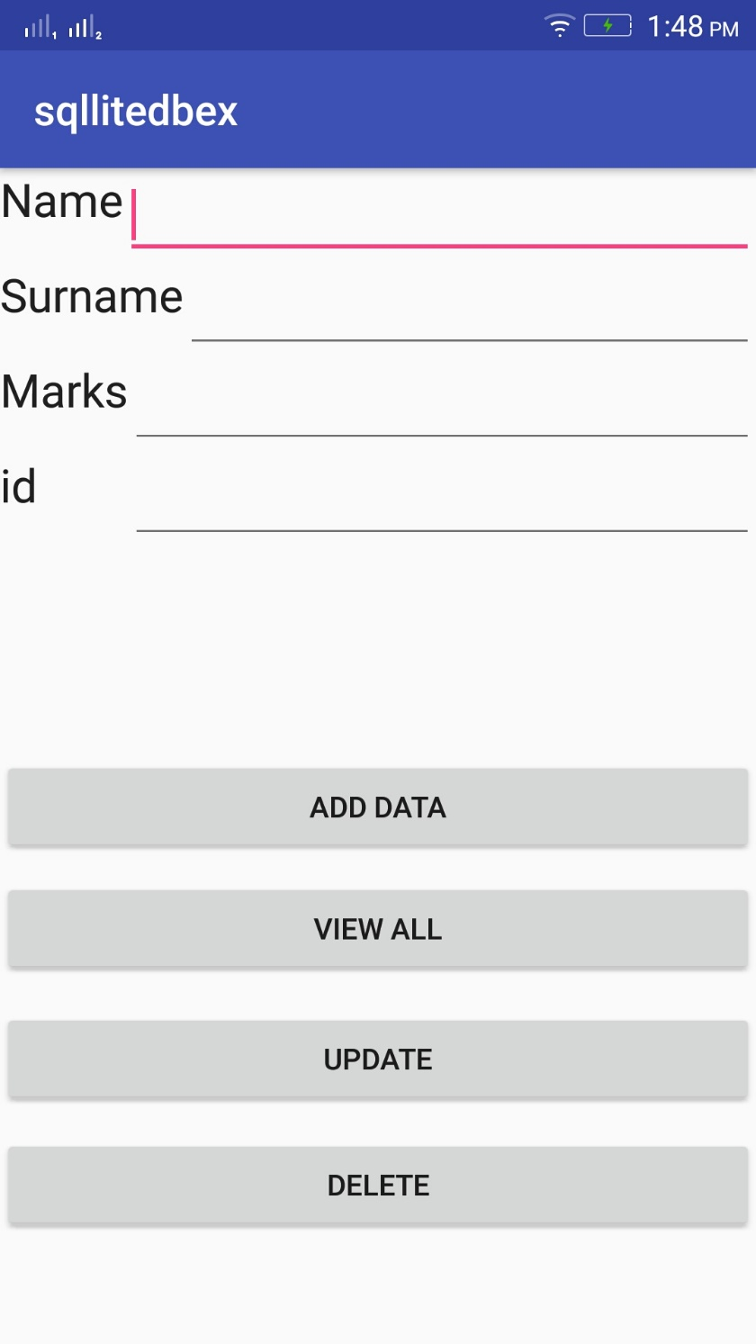

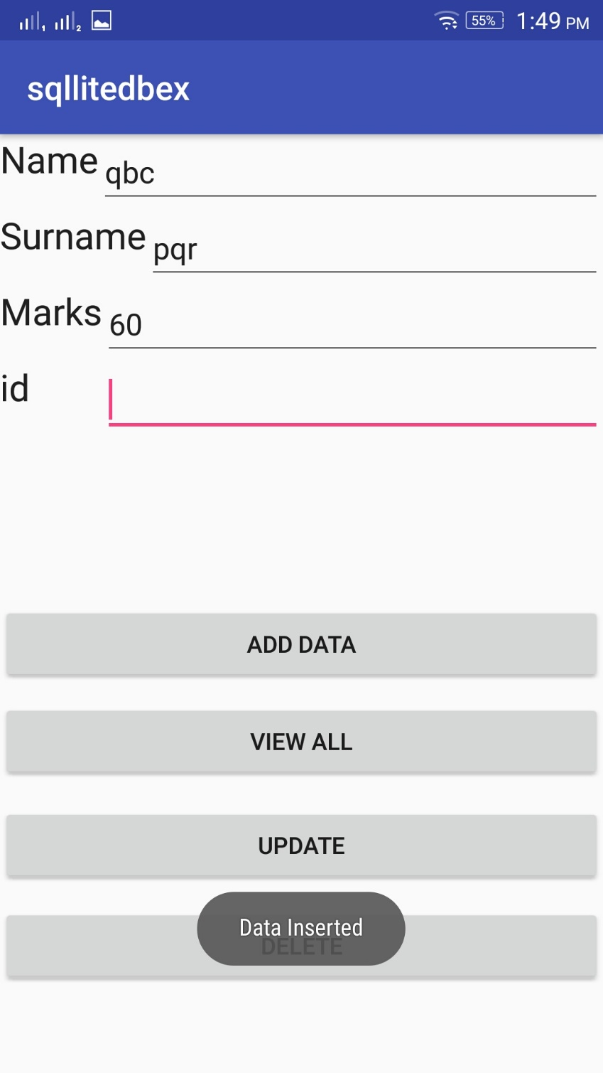

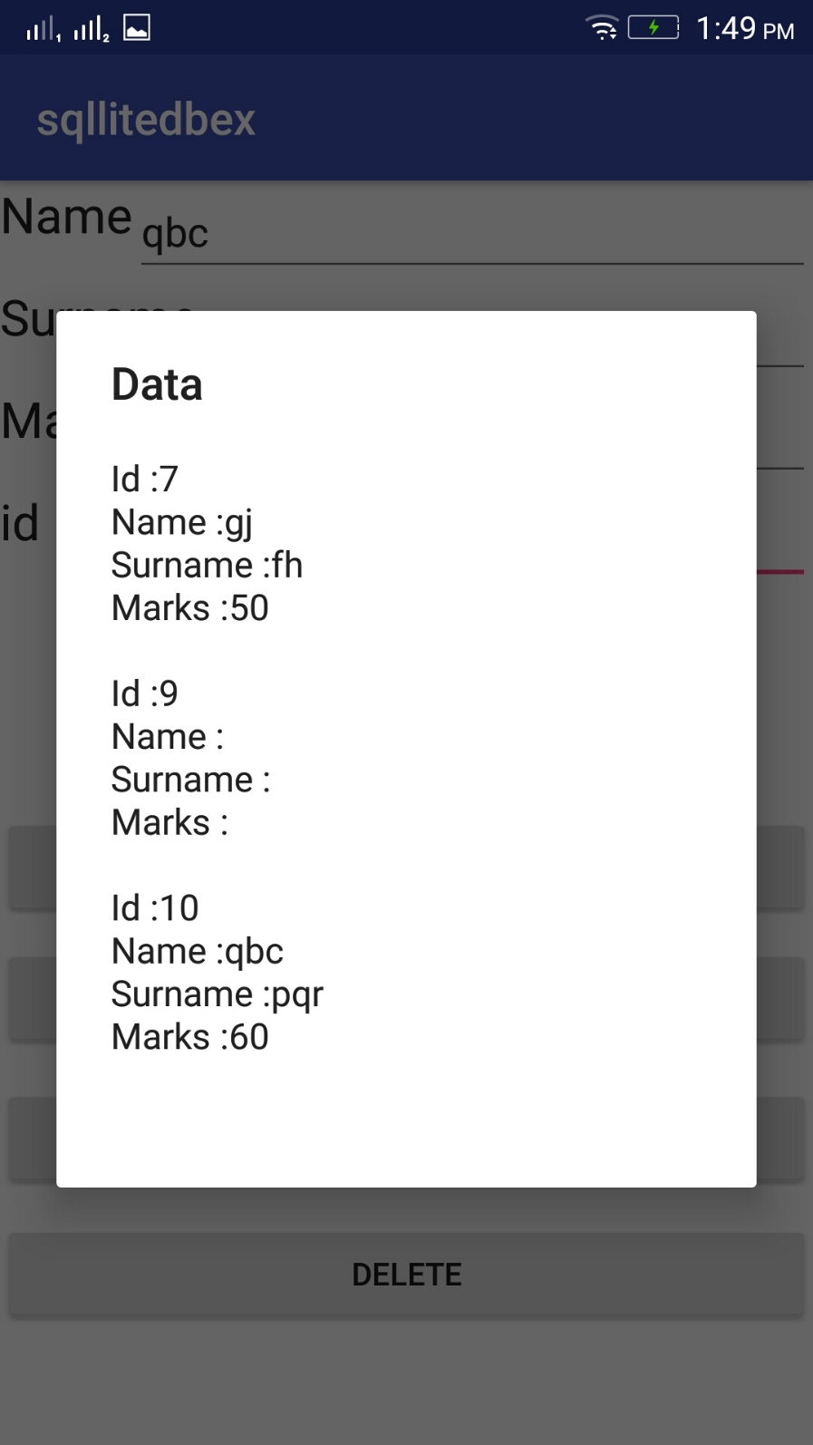

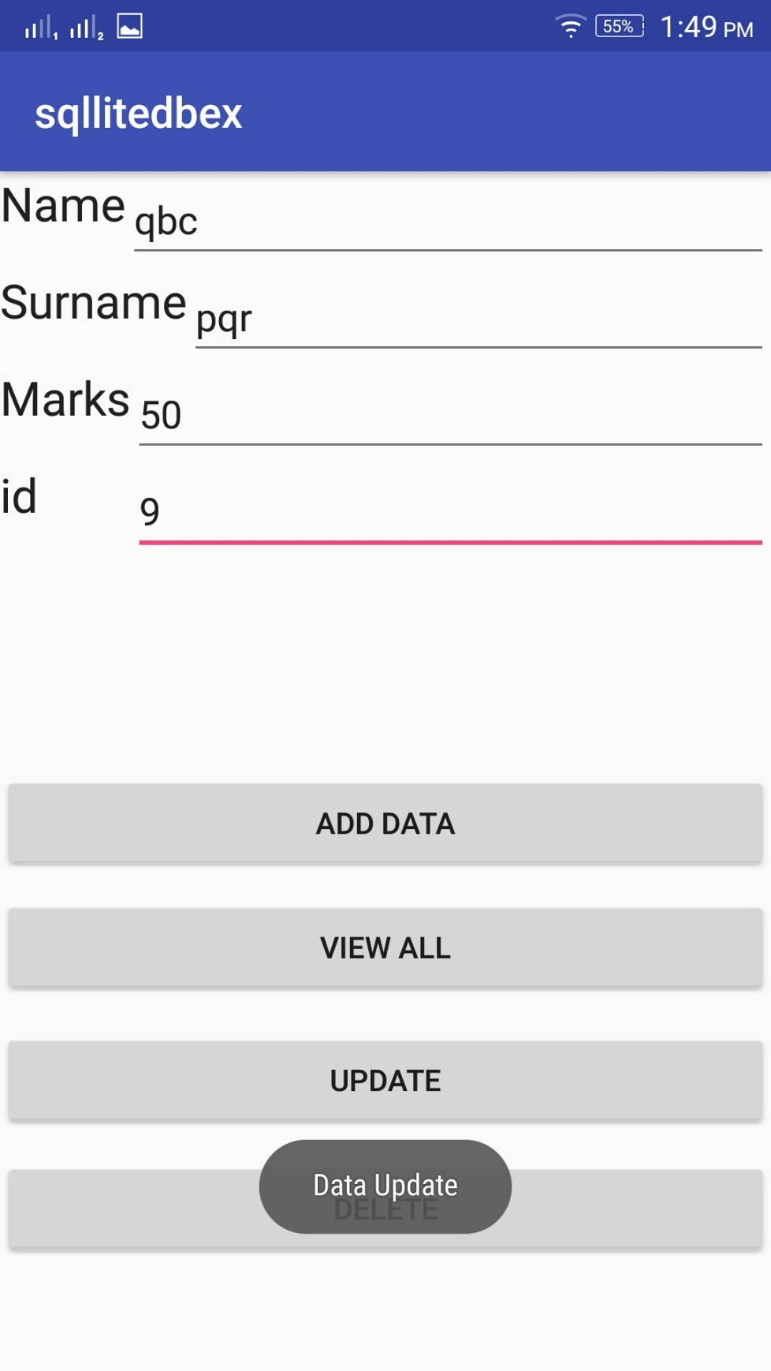

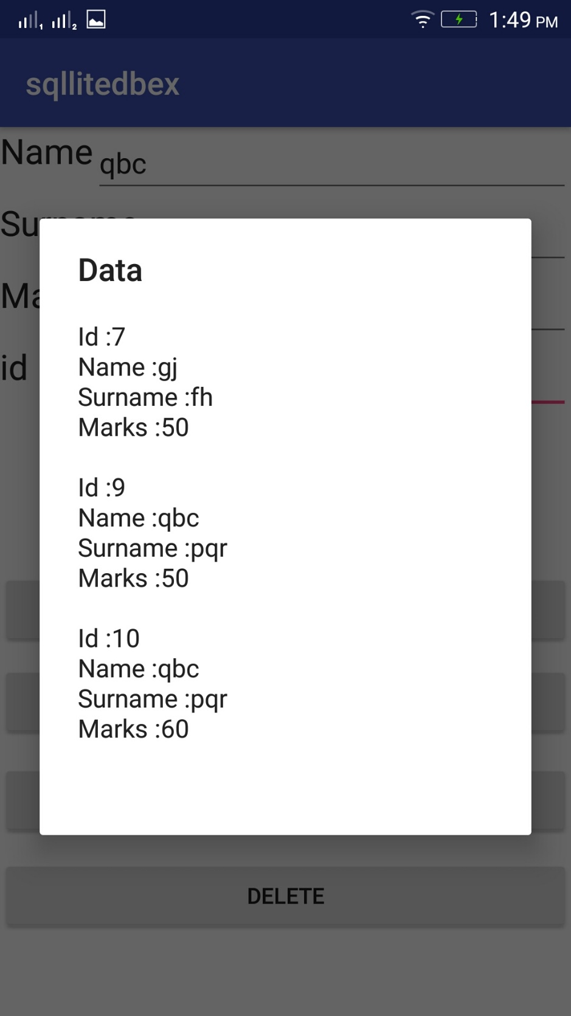

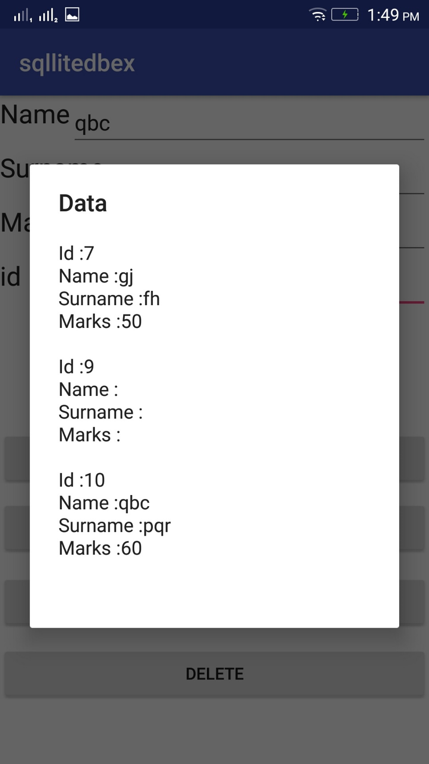

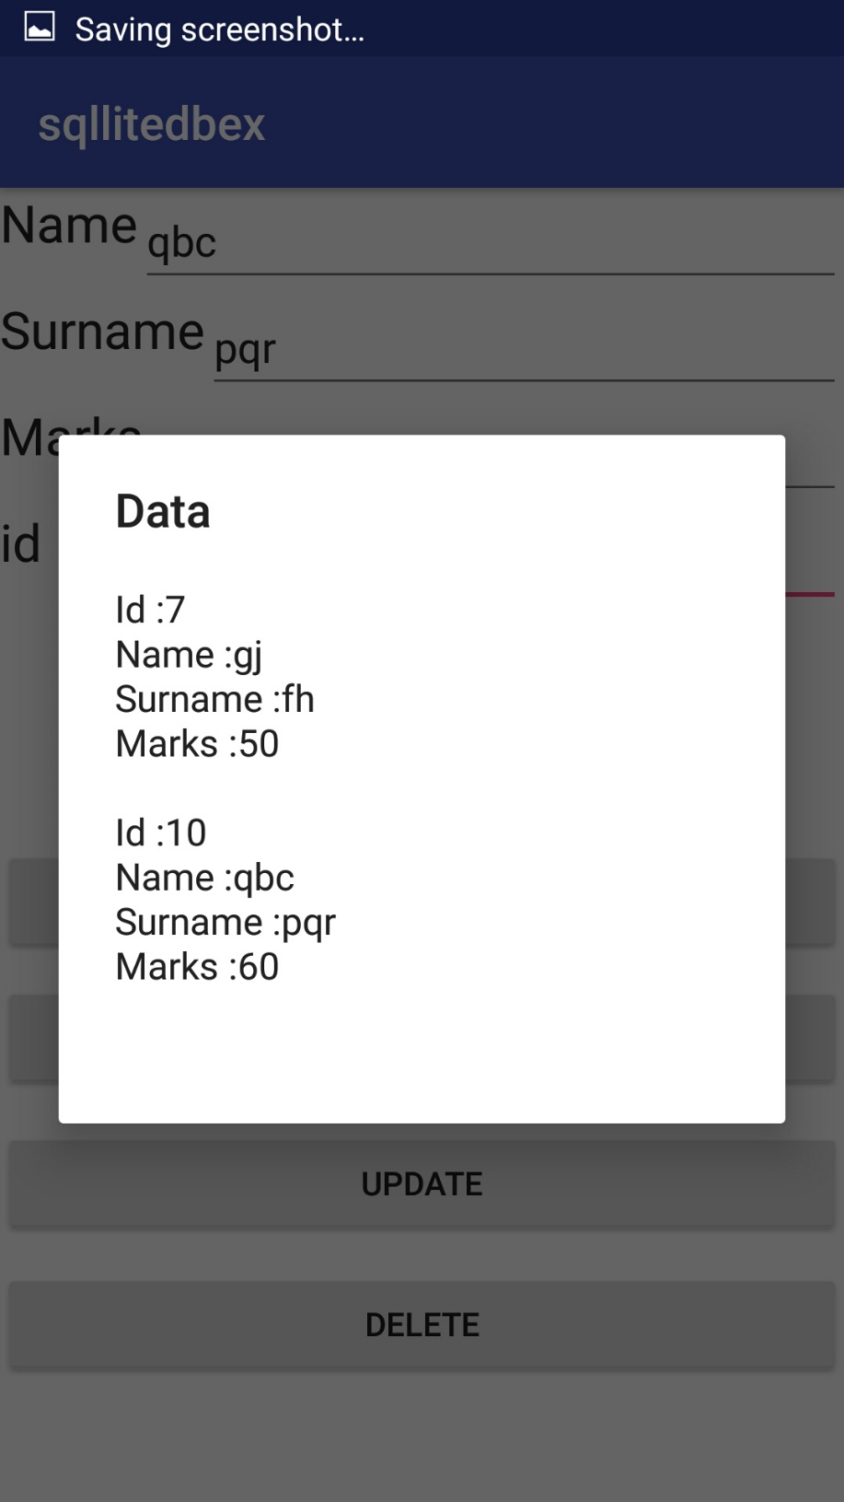

practical 7

**Aim: Programs on Media and Telephony API**

**A]Camera**

**AndroidManifest.xml**

*<?*xml version="1.0" encoding="utf-8"*?>*<manifest xmlns:android="http://schemas.android.com/apk/res/android"  
package="com.example.camera">  
  
<uses-feature  
android:name="android.hardware.Camera"  
android:required="true"></uses-feature>  
  
<application  
android:allowBackup="true"  
android:icon="@mipmap/ic_launcher"  
android:label="@string/app_name"  
android:roundIcon="@mipmap/ic_launcher_round"  
android:supportsRtl="true"  
android:theme="@style/AppTheme">  
<activity android:name=".MainActivity">  
<intent-filter>  
<action android:name="android.intent.action.MAIN" />  
  
<category android:name="android.intent.category.LAUNCHER" />  
</intent-filter>  
</activity>  
</application>  
  
</manifest>

**activity_main.xml**

*<?***xml version="1.0" encoding="utf-8"***?>*

<**RelativeLayoutxmlns:android="http://schemas.android.com/apk/res/android"**

**xmlns:app="http://schemas.android.com/apk/res-auto"**

**xmlns:tools="http://schemas.android.com/tools"**

**android:layout_width="match_parent"**

**android:layout_height="match_parent"**

**tools:context=".MainActivity"**>

<**Button**

**android:id="@+id/button"**

**android:layout_width="wrap_content"**

**android:layout_height="wrap_content"**

**android:text="Capture Pic"**

**android:layout_marginTop="200dp"**

**android:onClick="takepicture"**

**android:layout_centerHorizontal="true"**/>

<**ImageView**

**android:id="@+id/imageView"**

**android:layout_width="250dp"**

**android:layout_height="200dp"**

**app:srcCompat="@mipmap/ic_launcher"**

**android:layout_marginTop="25dp"**

**android:layout_centerHorizontal="true"**

**android:layout_below="@id/button"**/>

</RelativeLayout>

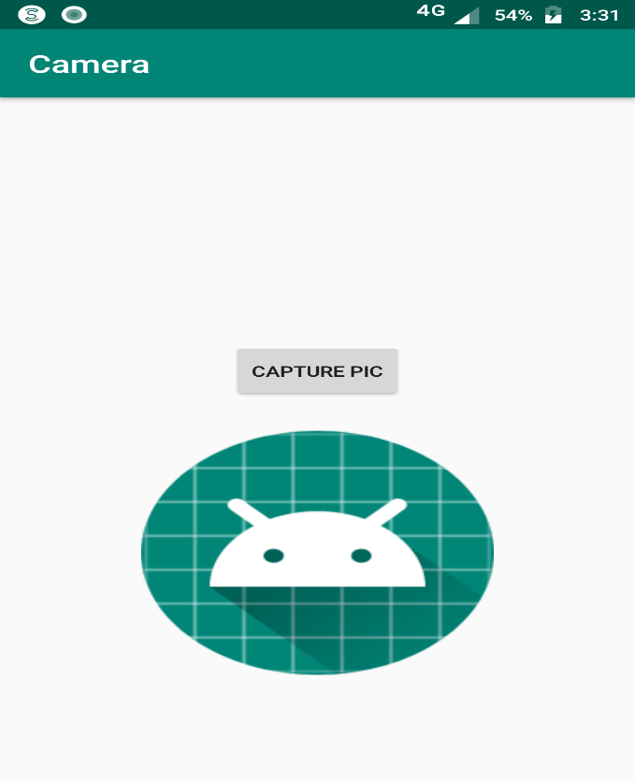

**MainActivity.java**

**package** com.example.camera;

**import** android.content.Intent;

**import** android.graphics.Bitmap;

**import** android.provider.MediaStore;

**import** android.support.annotation.Nullable;

**import** android.support.v7.app.AppCompatActivity;

**import** android.os.Bundle;

**import** android.view.View;

**import** android.widget.ImageView;

**public class** MainActivity**extends** AppCompatActivity {

**private** ImageView**mimageView**;

**private static final int *REQUEST_IMAGE_CAPTURE***= 101;

@Override

**protected void** onCreate(Bundle savedInstanceState) {

**super**.onCreate(savedInstanceState);

setContentView(R.layout.***activity_main***);

**mimageView**=(ImageView)findViewById(R.id.***imageView***);

}

**public void** takepicture(View view) {

Intent intent = **new** Intent(MediaStore.***ACTION_IMAGE_CAPTURE***);

**if** (intent.resolveActivity(getPackageManager())!=**null**)

{

startActivityForResult(intent,***REQUEST_IMAGE_CAPTURE***);

}

}

@Override

**protected void** onActivityResult(**int** requestCode, **int** resultCode, @Nullable Intent data) {

**if** (requestCode==***REQUEST_IMAGE_CAPTURE*** &&resultCode==***RESULT_OK***)

{

Bundle bundle = data.getExtras();

Bitmap bitmap = (Bitmap) bundle.get(**"data"**);

**mimageView**.setImageBitmap(bitmap);

}

}

}

Output:

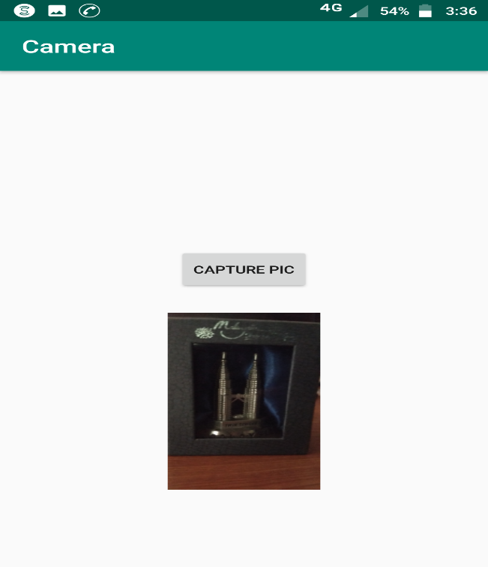

**B] Telephone API**

**AndroidManifest.xml**

*<?***xml version="1.0" encoding="utf-8"***?>*

<**manifest xmlns:android="http://schemas.android.com/apk/res/android"**

**package="com.example.callphone"**>

<**application**

**android:allowBackup="true"**

**android:icon="@mipmap/ic_launcher"**

**android:label="@string/app_name"**

**android:roundIcon="@mipmap/ic_launcher_round"**

**android:supportsRtl="true"**

**android:theme="@style/AppTheme"**>

<**activity android:name=".MainActivity"**>

<**intent-filter**>

<**action android:name="android.intent.action.MAIN"** />

<**category android:name="android.intent.category.LAUNCHER"** />

</**intent-filter**>

</**activity**>

</**application**>

<**uses-permission android:name="android.permission.CALL_PHONE"** />

</**manifest**>

Output: -

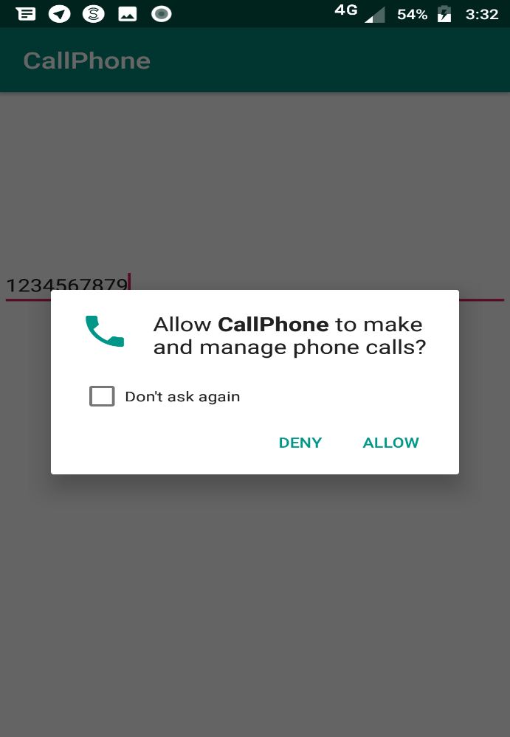

**activity_main.xml**

*<?***xml version="1.0" encoding="utf-8"***?>*

<**RelativeLayoutxmlns:android="http://schemas.android.com/apk/res/android"**

**xmlns:app="http://schemas.android.com/apk/res-auto"**

**xmlns:tools="http://schemas.android.com/tools"**

**android:layout_width="match_parent"**

**android:layout_height="match_parent"**

**tools:context=".MainActivity"**>

<**EditText**

**android:id="@+id/edit_text_number"**

**android:layout_width="match_parent"**

**android:layout_height="wrap_content"**

**android:layout_alignParentTop="true"**

**android:layout_marginTop="147dp"**

**android:inputType="phone"** />

<**ImageView**

**android:id="@+id/image_call"**

**android:layout_width="80dp"**

**android:layout_height="80dp"**

**android:layout_centerHorizontal="true"**

**android:layout_centerVertical="true"**

**android:src="@drawable/ic_phone"** />

</**RelativeLayout**>

Output: -

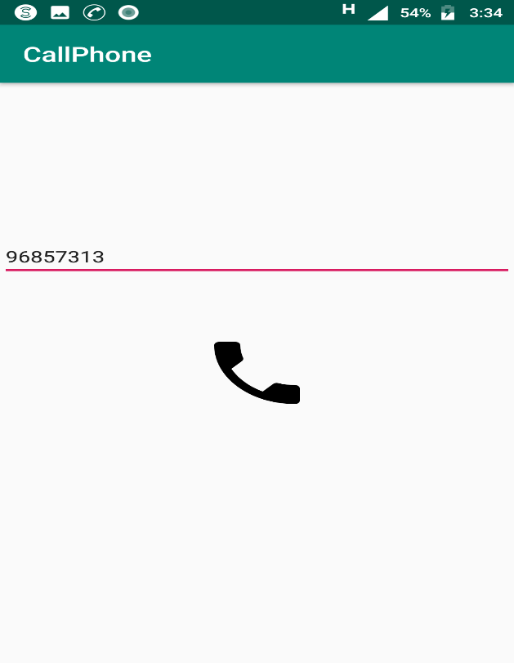

**MainActivity.java**

**package** com.example.callphone;

**import** android.Manifest;

**import** android.content.Intent;

**import** android.content.pm.PackageManager;

**import** android.net.Uri;

**import** android.support.annotation.NonNull;

**import** android.support.v4.app.ActivityCompat;

**import** android.support.v4.content.ContextCompat;

**import** android.support.v7.app.AppCompatActivity;

**import** android.os.Bundle;

**import** android.view.View;

**import** android.widget.EditText;

**import** android.widget.ImageView;

**import** android.widget.Toast;

**public class** MainActivity**extends** AppCompatActivity {

**private static final int *REQUEST_CALL*** = 1;

**private** EditText**mEditTextNumber**;

@Override

**protected void** onCreate(Bundle savedInstanceState) {

**super**.onCreate(savedInstanceState);

setContentView(R.layout.***activity_main***);

**mEditTextNumber**= findViewById(R.id.***edit_text_number***);

ImageViewimageCall = findViewById(R.id.***image_call***);

imageCall.setOnClickListener(**new** View.OnClickListener() {

@Override

**public void** onClick(View v) {

makePhoneCall();

}

});

}

**private void** makePhoneCall() {

String number = **mEditTextNumber**.getText().toString();

**if** (number.trim().length() >0) {

**if** (ContextCompat.*checkSelfPermission*(MainActivity.**this**,

Manifest.permission.***CALL_PHONE***) != PackageManager.***PERMISSION_GRANTED***) {

ActivityCompat.*requestPermissions*(MainActivity.**this**,

**new** String[]{Manifest.permission.***CALL_PHONE***}, ***REQUEST_CALL***);

} **else** {

String dial = **"tel:"** + number;

startActivity(**new** Intent(Intent.***ACTION_CALL***, Uri.*parse*(dial)));

}

} **else** {

Toast.*makeText*(MainActivity.**this**, **"Enter Phone Number"**, Toast.***LENGTH_SHORT***).show();

}

}

@Override

**public void** onRequestPermissionsResult(**int** requestCode, @NonNullString[] permissions, @NonNull**int**[] grantResults) {

**if** (requestCode == ***REQUEST_CALL***) {

**if** (grantResults.**length**>0 &&grantResults[0] == PackageManager.***PERMISSION_GRANTED***) {

makePhoneCall();

} **else** {

Toast.*makeText*(**this**, **"Permission DENIED"**, Toast.***LENGTH_SHORT***).show();

}

}

}

}

Output: -

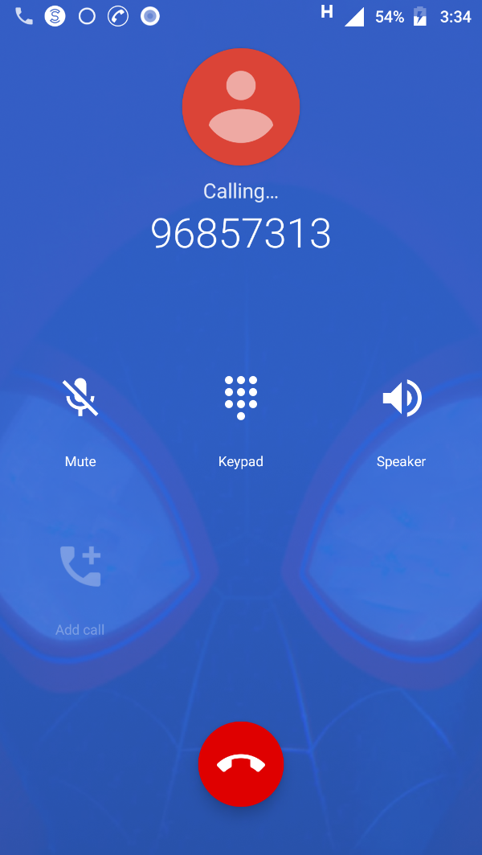

practical 8

**Aim: Programs on Permissions and security**

AndroidMainfest.xml

*<?***xml version="1.0" encoding="utf-8"***?>*<**manifest xmlns:android="http://schemas.android.com/apk/res/android"  
package="com.example.request"**>  
  
<**uses-permission android:name="android.permission.READ_EXTERNAL_STORAGE"**/>  
  
<**application  
android:allowBackup="true"  
android:icon="@mipmap/ic_launcher"  
android:label="@string/app_name"  
android:roundIcon="@mipmap/ic_launcher_round"  
android:supportsRtl="true"  
android:theme="@style/AppTheme"**>  
<**activity android:name=".MainActivity"**>  
<**intent-filter**>  
<**action android:name="android.intent.action.MAIN"** />  
  
<**category android:name="android.intent.category.LAUNCHER"** />  
</**intent-filter**>  
</**activity**>  
</**application**>  
  
</**manifest**>

activity_main.xml

*<?***xml version="1.0" encoding="utf-8"***?>*<**RelativeLayout xmlns:android="http://schemas.android.com/apk/res/android"  
xmlns:app="http://schemas.android.com/apk/res-auto"  
xmlns:tools="http://schemas.android.com/tools"  
android:layout_width="match_parent"  
android:layout_height="match_parent"  
tools:context=".MainActivity"**>  
  
<**Button  
android:id="@+id/button"  
android:layout_width="wrap_content"  
android:layout_height="wrap_content"  
android:text="Request Permission"  
android:layout_centerInParent="true"  
app:layout_constraiantBottom_toBottomOf="parent"  
app:layout_constraintLeft_toLeftOf="parent"  
app:layout_constraintRight_toRightOf="parent"  
app:layout_constraintTop_toTopOf="parent"** />  
  
</**RelativeLayout**>

MainActivity.java

**package** com.example.request;  
  
**import** android.Manifest;  
**import** android.app.AlertDialog;  
**import** android.content.DialogInterface;  
**import** android.content.pm.PackageManager;  
**import** android.support.annotation.NonNull;  
**import** android.support.v4.app.ActivityCompat;  
**import** android.support.v4.content.ContextCompat;  
**import** android.support.v7.app.AppCompatActivity;  
**import** android.os.Bundle;  
**import** android.view.View;  
**import** android.widget.Button;  
**import** android.widget.Toast;  
  
**public class** MainActivity **extends** AppCompatActivity {  
**private int STORAGE_PERMISSION_CODE** = 1;  
  
@Override  
**protected void** onCreate(Bundle savedInstanceState) {  
**super**.onCreate(savedInstanceState);  
 setContentView(R.layout.***activity_main***);  
  
  
 Button buttonRequest = findViewById(R.id.***button***);  
 buttonRequest.setOnClickListener(**new** View.OnClickListener() {  
@Override  
**public void** onClick(View v) {  
**if** (ContextCompat.*checkSelfPermission*(MainActivity.**this**,  
 Manifest.permission.***READ_EXTERNAL_STORAGE***) == PackageManager.***PERMISSION_GRANTED***) {  
 Toast.*makeText*(MainActivity.**this**, **"You have already granted this permission!"**,  
 Toast.***LENGTH_SHORT***).show();  
 } **else** {  
 requestStoragePermission();  
 }  
 }  
 });  
 }  
  
**private void** requestStoragePermission() {  
**if** (ActivityCompat.*shouldShowRequestPermissionRationale*(**this**,  
 Manifest.permission.***READ_EXTERNAL_STORAGE***)) {  
  
**new** AlertDialog.Builder(**this**)  
 .setTitle(**"Permission needed"**)  
 .setMessage(**"This permission is needed because of this and that"**)  
 .setPositiveButton(**"ok"**, **new** DialogInterface.OnClickListener() {  
@Override  
**public void** onClick(DialogInterface dialog, **int** which) {  
 ActivityCompat.*requestPermissions*(MainActivity.**this**,  
**new** String[] {Manifest.permission.***READ_EXTERNAL_STORAGE***}, **STORAGE_PERMISSION_CODE**);  
 }  
 })  
 .setNegativeButton(**"cancel"**, **new** DialogInterface.OnClickListener() {  
@Override  
**public void** onClick(DialogInterface dialog, **int** which) {  
 dialog.dismiss();  
 }  
 })  
 .create().show();  
  
 } **else** {  
 ActivityCompat.*requestPermissions*(**this**,  
**new** String[] {Manifest.permission.***READ_EXTERNAL_STORAGE***}, **STORAGE_PERMISSION_CODE**);  
 }  
 }  
  
@Override  
**public void** onRequestPermissionsResult(**int** requestCode, @NonNull String[] permissions, @NonNull **int**[] grantResults) {  
**if** (requestCode == **STORAGE_PERMISSION_CODE**) {  
**if** (grantResults.**length** >0 && grantResults[0] == PackageManager.***PERMISSION_GRANTED***) {  
 Toast.*makeText*(**this**, **"Permission GRANTED"**, Toast.***LENGTH_SHORT***).show();  
 } **else** {  
 Toast.*makeText*(**this**, **"Permission DENIED"**, Toast.***LENGTH_SHORT***).show();  
 }  
 }  
 }  
}

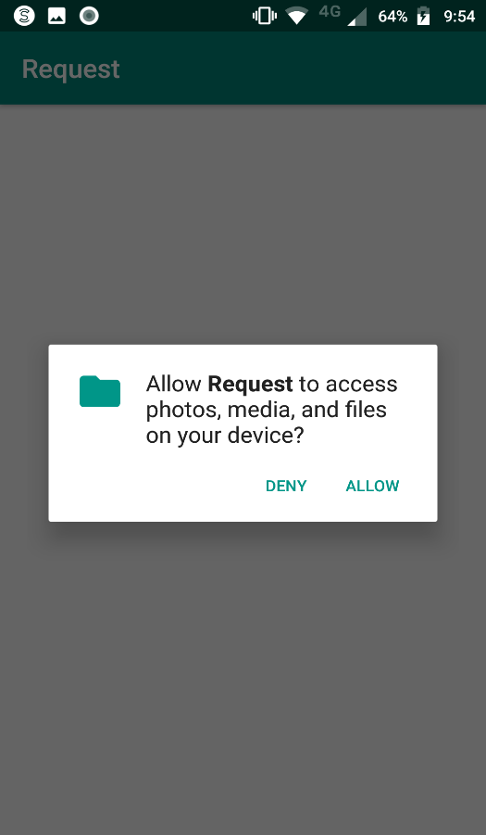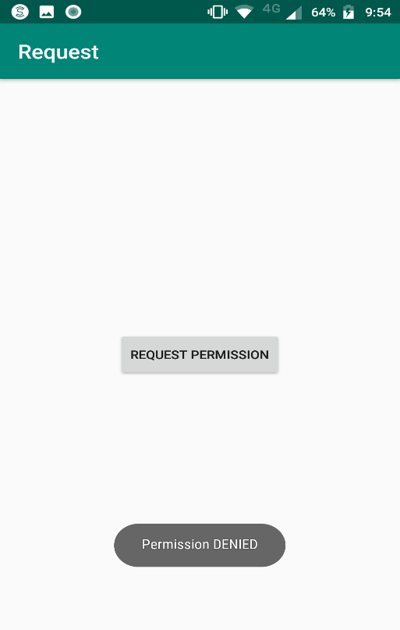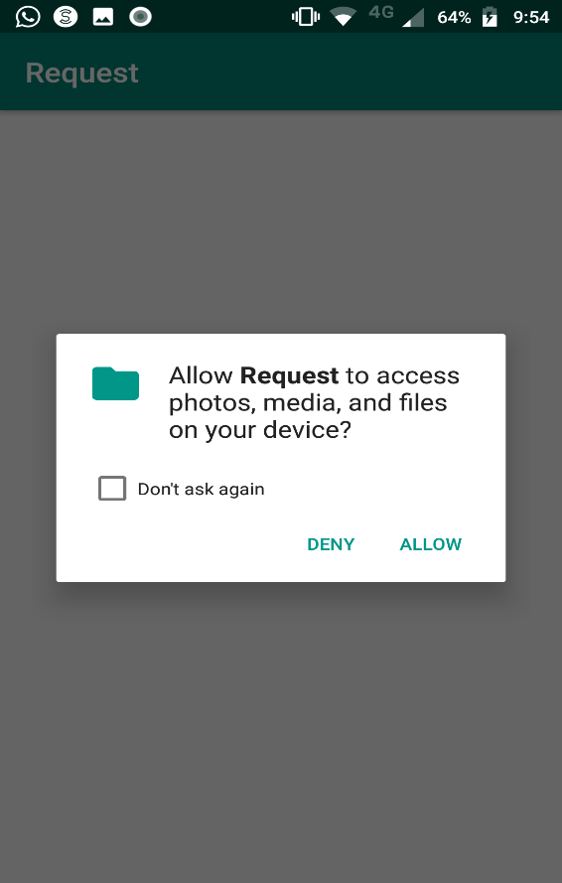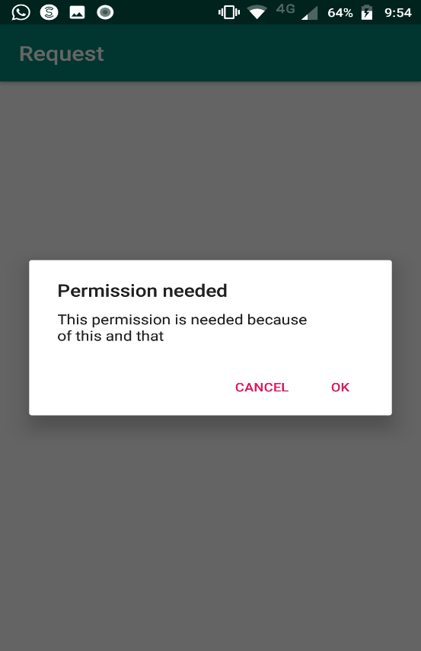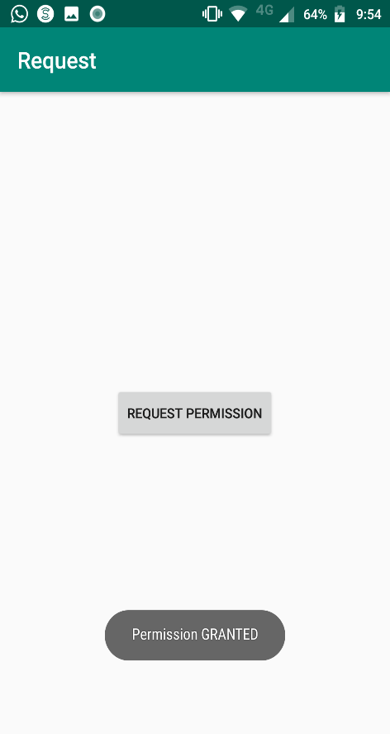

practical 9

**Aim: Programs on Activity Life cycle of android**

<?xml version="1.0" encoding="utf-8"?>

<android.support.constraint.ConstraintLayout xmlns:android="http://schemas.android.com/apk/res/android"

xmlns:app="http://schemas.android.com/apk/res-auto"

xmlns:tools="http://schemas.android.com/tools"

android:layout_width="match_parent"

android:layout_height="match_parent"

tools:context="example.javatpoint.com.activitylifecycle.MainActivity">

<TextView

android:layout_width="wrap_content"

android:layout_height="wrap_content"

android:text="Hello World!"

app:layout_constraintBottom_toBottomOf="parent"

app:layout_constraintLeft_toLeftOf="parent"

app:layout_constraintRight_toRightOf="parent"

app:layout_constraintTop_toTopOf="parent" />

</android.support.constraint.ConstraintLayout>

**MainActivity.java**

package example .com.activitylifecycle;

import android.app.Activity;

import android.os.Bundle;

import android.util.Log;

public class MainActivity extends Activity {

@Override

protected void onCreate(Bundle savedInstanceState) {

super.onCreate(savedInstanceState);

setContentView(R.layout.activity_main);

Log.d("lifecycle","onCreate invoked");

}

@Override

protected void onStart() {

super.onStart();

Log.d("lifecycle","onStart invoked");

}

@Override

protected void onResume() {

super.onResume();

Log.d("lifecycle","onResume invoked");

}

@Override

protected void onPause() {

super.onPause();

Log.d("lifecycle","onPause invoked");

}

@Override

protected void onStop() {

super.onStop();

Log.d("lifecycle","onStop invoked");

}

@Override

protected void onRestart() {

super.onRestart();

Log.d("lifecycle","onRestart invoked");

}

@Override

protected void onDestroy() {

super.onDestroy();

Log.d("lifecycle","onDestroy invoked");

}

}

Output:

